**Student led society whose purpose is to engage with sustainability.**

* **Fab Lab Project in the Faculty of Engineering - Alexandria University**

The overall goal of the project is to develop the circular and creative economy model by creating an innovation place equipped with machines Low Tech in Alexandria is hosted by Alexandria University. This place will play a role in creating local dynamism Transversal to become a crossroads between different audiences and actors from different backgrounds. To connect waste collection Plastic and its evaluation. Horizons Solidarités and the University of Corsica, in partnership with their peers in Alexandria, based on their experience in Fab Lab Corte, conduct experiments on recreating value for plastic in Alexandria. The goal is to connect all actors from assembly through training to development and dissemination.

The scope of work in the project

• Environment, climate, and energy

• Education, social aspect, and research

These goals will be implemented through the establishment of a FabLab within Alexandria University, which is a space for innovation. Derives place this innovation is energized by a generation that has innovative ideas in the fields of environment, citizenship, and culture. This revival is embodied in women and the men who are partners in the project. The high skills of Alexandria University and Senghor University, Francophone operator in Alexandria, ensures the long-term commitment of their students and the sustainability of the local dynamism. Implementation benefits from facilities Headquarters provided by Alexandria University Project Engine. VSI contributes to the unification of links between regions. Project depends on the Alexandria Business Association (ABA), a trade organization that invests in creating startups in the circular economy and selling finished products. A multi-representative consortium from both sides of the Mediterranean could be formed from these dynamics that will support the project over time.

|  |
| --- |
|  |
|  |
|  |
| Eco Fab Alexandria  The Eco Fab is a fab lab dedicated to plastic recycling in Alexandria, Egypt and part of PECA project (Circular economy hub in alexandria). |

* Raising awareness among Alexandria University students from various faculties—including Science, Engineering (Civil, Mechanical, and Mechatronics), Commerce, Arts (Surveying, mapping, and GIS), and Fine Arts (Architecture)—about wastewater treatment was achieved through summer training and periodic visits to the laboratories of the Alexandria Sewerage Company. This effort supports the achievement of the Sustainable Development Goals by enhancing partnerships for sustainable development and fostering collaborations that mobilize and share knowledge, expertise, and technology. The training aimed to provide students with essential scientific skills and practical experience to prepare them for the job market (September 2024).
* **Faculty of Science:** Theoretical training introduced the role of the Sewerage Company, while practical training involved visits to treatment plants, central laboratories, and lectures on occupational safety and industrial sewage.
* **Faculty of Arts (Surveying, mapping, and GIS):** Training included surveying applications, urban planning, and the practical use of leveling instruments, total stations, and GPS devices, concluding with lessons on ArcGIS and sewage system design.
* **Engineering Colleges:** Civil Engineering students trained in network renewal and design, while Mechanical and Mechatronics students learned about pump components, welding, and electrical generators, with visits to various workshops.

**Fine Arts (Architecture):** Students received training on project design drawings and estimating costs.

* A cooperation protocol was signed between Alexandria University and Alexandria Sewerage Company to employ outstanding graduates from the faculties of Engineering, Commerce, Law, Science, and Arts over the past five years, based on the actual needs and annual workforce plan of the sewerage company. Additionally, the protocol aims to prepare a new generation of skilled professionals in modern technologies. It includes agreements for employees to access master's and doctoral programs at reduced fees and to conduct workshops and training courses with professors from Alexandria University to enhance partnerships for sector performance and achieve sustainable development goals.
* Raising awareness among university staff and students about water conservation through seminars and workshops organized in collaboration with the Alexandria Drinking Water Company, in order to Strengthen the means of implementation and revitalize the global partnership for sustainable development.
* International Collaboration and Partnerships is performed by collaborating with other countries and institutions to share knowledge, technology, and expertise on GHG emission reduction.

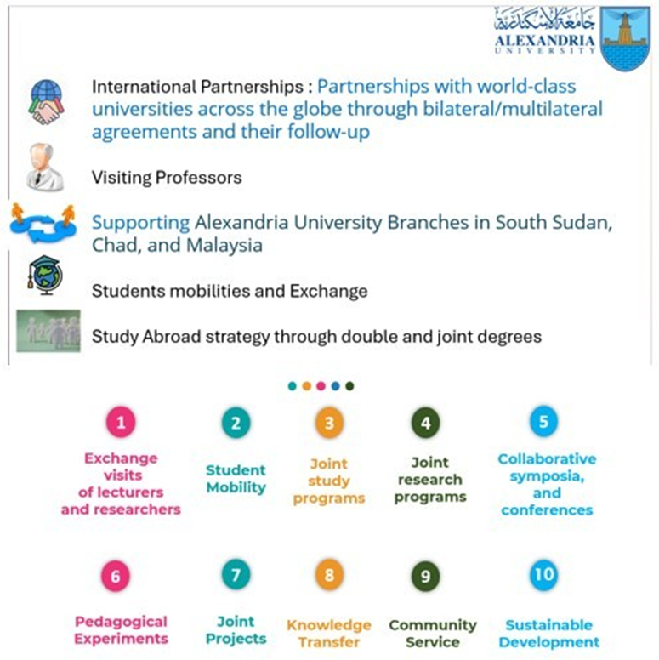

* On June 18, 2024, Students from various schools in Alexandria, along with students from the French Institute in Alexandria, collaborated with Alexandria University to participate in a large-scale cleanup campaign titled **”Our Sea is Clean Without Trash** ’x,’ 🌊**.”** for Anfouchi beach. After cleaning the beach, the students discovered the process of transforming plastic waste through 3D printing at the Fab Lab at Alexandria University. This initiative is part of the "Circular Economy: From the Beach to the Lab" project, led by the French Consulate and the French Institute in Alexandria, with financial support from the European Union and in cooperation with the Alexandria Governorate and Alexandria University. The project aims to achieve partnerships for sustainability goals and to engage the local community in these efforts.

|  |
| --- |
|  |
| **Students from various schools in Alexandria, alongside those from the French Institute, participated in a large-scale cleanup campaign at Anfouchi beach titled “Our Sea is Clean Without Trash** ’x,’ 🌊**.” Following the cleanup, participants explored the process of transforming plastic waste into usable materials through 3D printing at the Fab Lab at Alexandria University. This initiative is part of the "Circular Economy: From the Beach to the Lab" project, led by the French Consulate and the French Institute, with financial backing from the European Union and collaboration with the Alexandria Governorate. The project aims to foster partnerships for sustainability and actively engage the**  **local community in environmental efforts.** |

* President of Alexandria University, met with the Chinese Consul General in Alexandria, to discuss enhancing cooperation between the university and Chinese institutions. The discussion, attended by various university officials, focused on establishing partnerships in areas such as clean energy, water desalination, artificial intelligence, and the study of Arabic and Chinese languages. Ambassador Yang proposed collaboration by sending Chinese professors to teach at the Faculty of Arts and facilitating student exchanges to study Chinese language and culture in China.

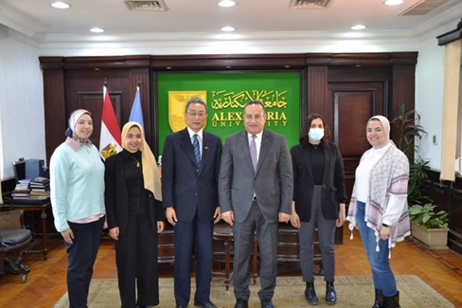

* Raising awareness among university staff and students about water conservation through seminars and workshops organized in collaboration with the Alexandria Drinking Water Company, in order to Strengthen the means of implementation and revitalize the global partnership for sustainable development.
* 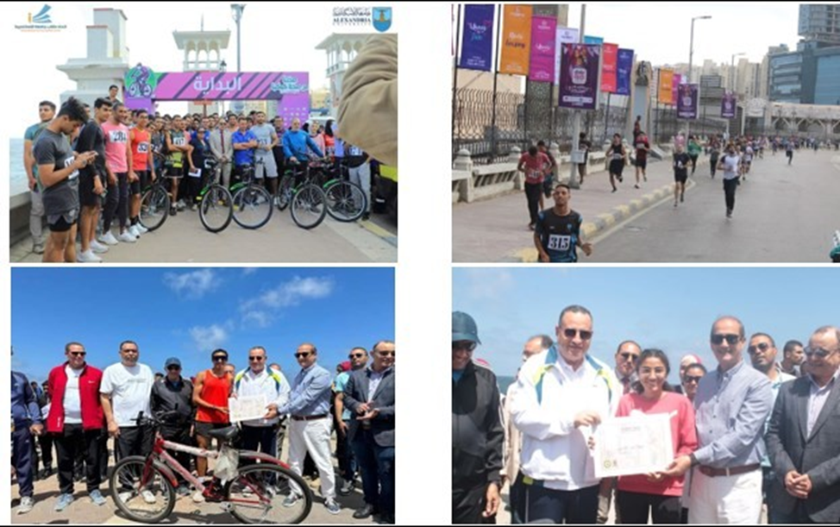In an effort to raise environmental awareness among students and the local community in Alexandria, the Faculty of Sport Education Abo Qir organized an event titled 'Our Health is in Our Planet' in collaboration with the Ministry of Environment and Sanofi on May 4, 2024. The marathon started in front of Stanley Bridge and ended at the University Administration Building in Shatby. The top 20 (male and female) student winners were awarded 20 bicycles.
* The Minister of Higher Education chairs the meeting of the Supreme Council of Universities at Alexandria University supporting the “**Egypt Digital Cubs” initiative organized by the Ministry of Communications and Information Technology, by allowing the use of electronic testing laboratories spread throughout all public universities**, to conduct admission tests for applicants, by activating a tripartite cooperation protocol between the Ministry of Higher Education and Scientific Research, the Ministry of Communications and Information Technology, and the presidents of public universities**. The Ministry launched the green financing initiative for research, development and innovation to support applied projects that contribute to solving environmental problems, nature conservation, clean energy, waste recycling**, etc. They also reviewed the ongoing partnerships between the Ministry and various countries of the world, the Association of African Universities, and the Union of Arab Universities.

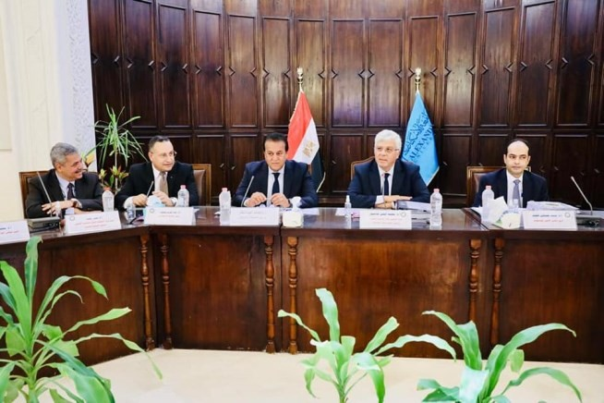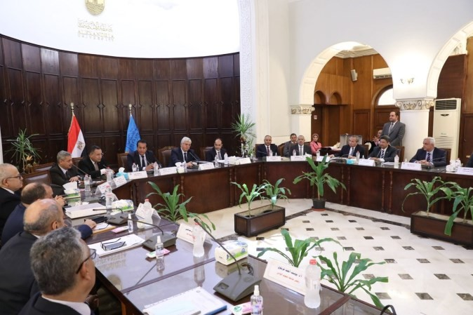

* **Smart Environmental Management of Climate Change in collaboration with Catania University, Italy**

2 year Postgraduate Master program (4 semesters).

AdapTm-Erasmus project: The participating countries and Universities: Italy, Greece, Lithuania, Slovenia, Egypt (Alexandria University, Suez Canal University, South Valley University, Arab Academy for Science and Technology and Maritime Transport). Program start date: year 2019

|  |
| --- |
|  |
| Smart Environmental Management of Climate Change Master Program (Alexandria University, Egypt) |

* **Sustainable Management of Fisheries and Aquaculture Science, in collaboration with University of Aveiro, Portugal.**

2 year Postgraduate Master program (4 semesters).

(Erasmus+ Project, European Union): The participating countries and Universities: Portugal (University of Aveiro), Italy, Croatia, Slovenia, Egypt (Alexandria University, Aswan University, Matrouh University, Arab Academy for Science and Technology and Maritime Transport). Program start date: year 2021

|  |
| --- |
|  |
| Sustainable Management of Fisheries and Aquaculture Science Master Program (Alexandria University, Egypt) |

* **Natural Resources Sustainability for Land Development in collaboration with Aachen University, Germany**

2 year Postgraduate Master program (4 semesters).

Erasmus+ Project, European Union: The participating countries and Universities: Germany (RWTH Aachen), Egypt (Alexandria University, Heliopolis University, the American University in Cairo, Aswan University), Cyprus (CITY College – Sheffield University), Italy (University of Palermo), Spain (Technical University of Madrid). Program start date: year 2022

|  |
| --- |
|  |
| Natural Resources Sustainability for Land Development Master Program (Alexandria University, Egypt) |