Mandatory annual dedicated training on environmental aspects of sustainability for staff members
As part of its commitment to sustainable development for improving environmental affairs and serving the community, Alexandria University has taken a pioneering role, being the first among Egyptian universities to adopt the idea of creating a comprehensive guide for correct procedures and practices that meet infection control recommendations within its facilities that serve students. This extends not only to the clinics in the colleges and institutes of the university but also to student residences, lecture halls, classrooms, laboratories, sports fields, and various other facilities frequented by students at Alexandria University. The vision behind the university's initiative to develop this guide is to establish a framework for practices, behaviors, and requirements for all students and staff at Alexandria University, based on the principles and guidelines of infection control. This guide will serve as a reference for safeguarding the health and safety of students and staff, ensuring sustainability, and positively impacting the community in Alexandria. It will also serve as a model in this regard, with the guide being made easily accessible to the target audience both in printed format and electronically for ease of use and review when needed by all students and staff.
Each Faculty at Alexandria University has a student team for occupational safety and health. The student attend several workshops during the academic year. Workshops, seminars, and awareness campaigns educate the students about safety and health issues, including fire safety and personal safety. The student teams play a crucial role in promoting and maintaining a safe and healthy environment.
Solar Energy Center at the Faculty of Agriculture (Alexandria University) supported the renewable energy education at AU, developed and delivered courses, e-learning, workshops, training courses, and conferences on various renewable energy systems.
Raising awareness among Alexandria University students from various faculties—including Science, Engineering (Civil, Mechanical, and Mechatronics), Commerce, Arts (Surveying, mapping, and GIS), and Fine Arts (Architecture)—about wastewater treatment was achieved through summer training and periodic visits to the laboratories of the Alexandria Sewerage Company. This effort supports the achievement of the Sustainable Development Goals by enhancing partnerships for sustainable development and fostering collaborations that mobilize and share knowledge, expertise, and technology. The training aimed to provide students with essential scientific skills and practical experience to prepare them for the job market (September 2024).
- Faculty of Science: Theoretical training introduced the role of the Sewerage Company, while practical training involved visits to treatment plants, central laboratories, and lectures on occupational safety and industrial sewage.
- Faculty of Arts (Surveying, mapping, and GIS): Training included surveying applications, urban planning, and the practical use of leveling instruments, total stations, and GPS devices, concluding with lessons on ArcGIS and sewage system design.
- Engineering Colleges: Civil Engineering students trained in network renewal and design, while Mechanical and Mechatronics students learned about pump components, welding, and electrical generators, with visits to various workshops.
- Fine Arts (Architecture): Students received training on project design drawings and estimating costs.
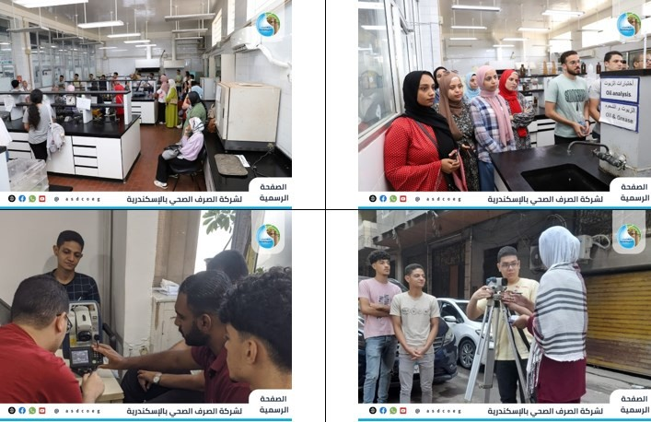
Raising awareness among Alexandria University students about wastewater treatment was achieved through summer training activities conducted at Alexandria Sewerage for students from various faculties, including Science, Engineerin, Commerce, Arts, and Fine Arts
(Architecture)

A cooperation protocol was signed between Alexandria University and Alexandria Sewerage Company to employ outstanding graduates from the faculties of Engineering, Commerce, Law, Science, and Arts over the past five years, based on the actual needs and annual workforce plan of the sewerage company. Additionally, the protocol aims to prepare a new generation of skilled professionals in modern technologies. It includes agreements for employees to access master's and doctoral programs at reduced fees and to conduct workshops and training courses with professors from Alexandria University to enhance partnerships for sector performance and achieve sustainable development goals.
The Center of Excellence for Water is organizing a training program for scholarship students. This training is conducted in collaboration between the Water Excellence Center at Alexandria University and EPROM Company to provide a course for a group of students from the Water Excellence Center. This initiative reflects Alexandria University’s commitment to equipping its students with practical skills related to water management, ensuring they possess the competencies needed by the business sector while aligning their studies with labor market requirements. The Center of Excellence for Water at Alexandria University has organized a training program for students in the Water Excellence Center Scholarship and the Civil and Environmental Engineering Program. Alexandria University, EPROM Company, and the students are participating in the following two training programs:
• Water Treatment for Industrial Applications
• Wastewater Plant Operations and Troubleshooting.
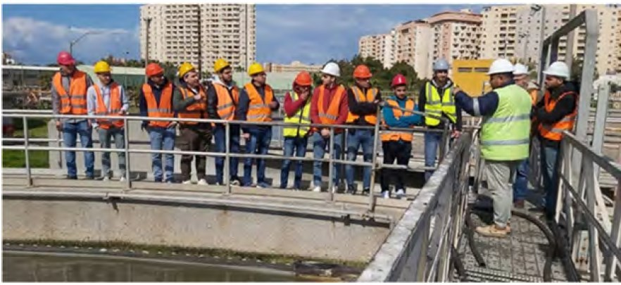
Water Excellence Center - Alexandria University
Training for civil and environmental engineering students at the Eastern Wastewater Treatment Plant in Alexandria

Botanic Garden (Faculty of Science in Moharram Bek)
The university botanic garden at the Faculty of Science is valuable to the educational and training facilities available to staff and students. In it, students can come to close intimacy with plants, use their senses of touch, smell and taste in familiarizing themselves with life features of plants, and develop their observation abilities in studying plants as they grow, mature and regenerate. Information intake is considerable. Land plots, greenhouses and sheds provide space for field experiments that may be part of botanical garden accumulates experiences and knowledge related to plant life; grasping this wealth of information and documenting it is a most welcome enterprise.
University botanic gardens often accommodate exotic species brought in to represent: (1) diverse ecological conditions in world biogeographical regions, and (2) diverse taxonomic groups of the plant kingdom. Husbanding and nursing these alien plants may need innovative means. This broadens the scope of work. The University botanical garden of Alexandria has its shares of these general attributes.
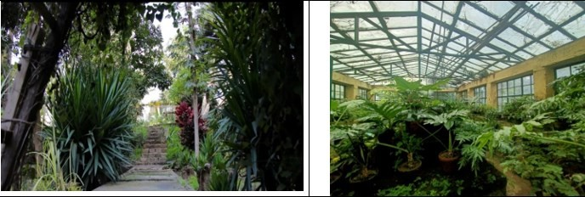
Botanic Garden (Faculty of Science in Moharram Bek) | Botanic Garden, Green House (Faculty of Science in Moharram Bek)

Events Related to Sustainability
Number of events related to environment and sustainability hosted or organized by the Alexandria University in academic year 2022-2023 are more than 247 events.

Examples of some activities with description and photos:
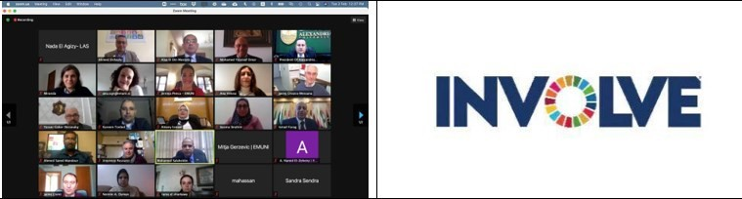
The opening of the activities of the project “Integrating Sustainable Development Goals into Universities for Better Management of Climate Change,” which is funded by the European Union within the Erasmus Plus program (2021-2024) with a budget of 15 million pounds, via the electronic platform, and its work continued over two days. Alexandria University is leading the project, which includes 7 other partners, from the European Union, namely the University of Aveiro in Portugal, the University of Sassari in Italy, the University of Valencia in Spain, the Euro-Mediterranean University from Slovenia, and from Egypt the Arab Academy for Science, Technology and Maritime Transport, Zewail University, and Heliopolis University. The project aims to enhance the capabilities of Egyptian universities in terms of raising awareness of sustainable development goals for university members, integrating sustainable development goals
into strategic plans and university policies, and transforming universities into environmentally sustainable universities.

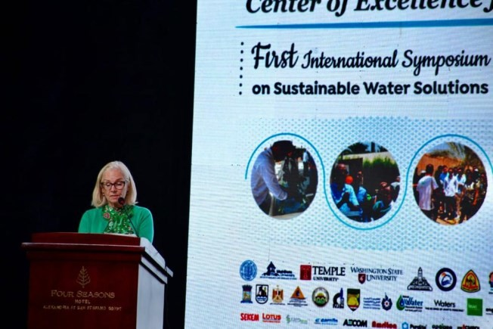 | 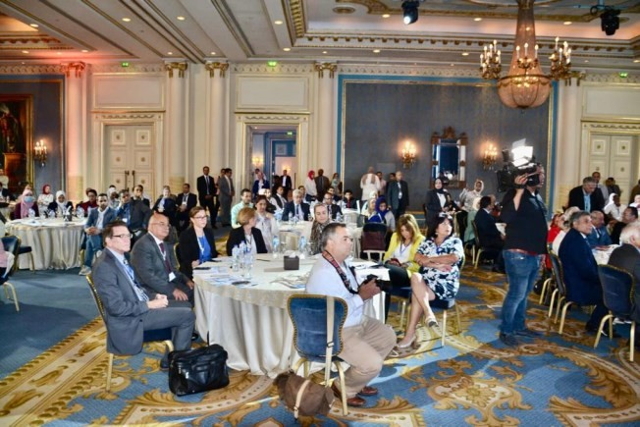
The First International Symposium on Sustainable Water Solutions in Alexandria, organized by the Center for Water Excellence at Alexandria University (funded by the United States Agency for International Development in Cairo, USAID, and in partnership with a coalition of Egyptian and American universities with the aim of supporting learning and
research in the field of water).
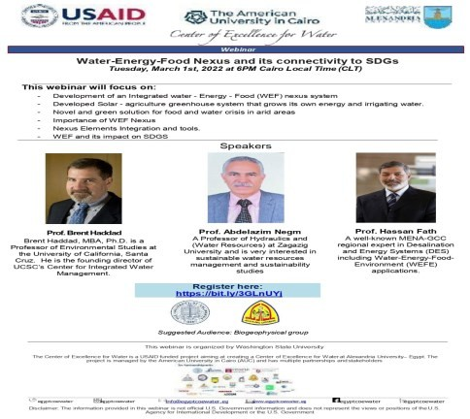
In the frame of the webinar series, the Center of Excellence for Water organized the twenty first webinar with California Santa Cruz University and Zagazig, entitled: "Water Energy Food Nexus and its connectivity to SDGs"
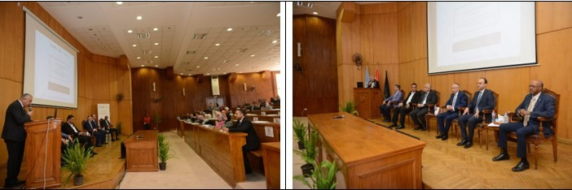
Seminar on "Management, Sustainability and Strategic Planning of the Center of Excellence for Water” at Faculty of
Engineering. The project of the Water Excellence Center at Alexandria University is working to find solutions to the expected water problems in light of population growth and the serious challenges we are currently facing in Egypt.

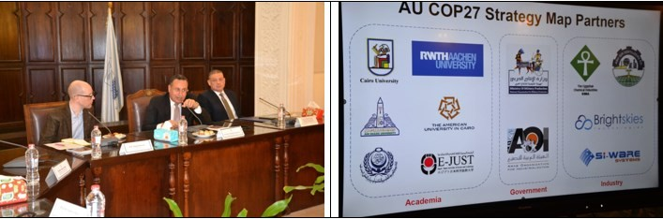
Discussing ways of cooperation between Alexandria University and the Vice President of the Climate Group at the University of Cambridge in Britain and the official for international cooperation in the COP26 university network on the issue of climate change and ways to enhance academic and research relations and aspects of joint cooperation in preparation for the COP27 conference. The attendees gave a presentation on Alexandria University’s projects in the field of environmental sustainability in preparation for the COP27 climate conference, and included projects on the production of green and grey hydrogen, the design and manufacture of electric vehicles, the establishment of the Alexandria University Company for Energy and Water Services, and the establishment of an electronic components manufacturing center, in addition to preparing studies on diversifying energy sources. Egypt's role as a regional energy
center and the contributions of the Suez Canal to reducing carbon emissions at the international level.
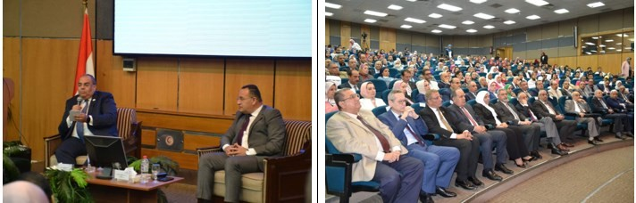
Alexandria University held a symposium on “Climate Change and Green Transformation: The Vision of Alexandria University with several universities and scientific bodies to participate in the COP27 climate conference. These projects include the use of green hydrogen and green ammonia in the fertilizer industry in cooperation with the Egyptian Chemical Industries Company (Kima), the establishment of the Alexandria University Company for Energy and Water Services, the localization of the electric car industry inside Egypt through the design and manufacture of the electric bus and the electric car, the role of the Suez Canal in reducing carbon emissions on the global level, the establishment of the Alexandria University Centre for the blue-green economy, the role of Egypt as a regional centre for Energy, the production of green and grey hydrogen, the establishment of the Electronic Components Manufacturing Centre, in addition to the establishment of the Alexandria University Centre for Sustainable Development, with the aim of achieving sustainable development goals within the Alexandria University campus in order to turn it into a green
university.

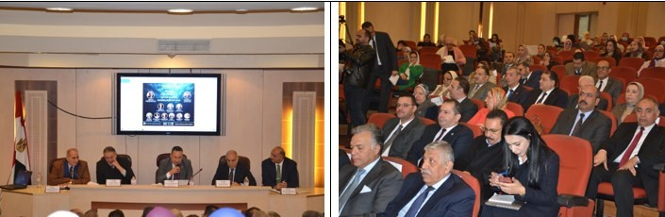
The first activity of the Greener Blue Economy Center at Alexandria University, a workshop held under the title "Sustainable Blue Economy Issues in the Mediterranean Basin Countries", in the Conference Hall at the Faculty of Commerce, generating electricity from water energy, mining activities in the seas and oceans, marine tourism, fishing
activities, extracting raw materials from the sea, and other forms of economic activity mainly related water resources.
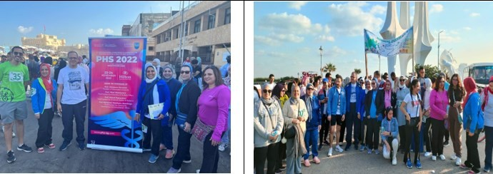
Faculty of Pharmacy, in cooperation with the students of the Scientific Society of Faculty of Pharmacy, organized a sports marathon for walking and cycling under the title "Running for Green" within the framework of the preparations of Faculty of Pharmacy and University of Alexandria for the Climate Change Conference COP27 which was held in Sharm
el-Sheikh in November 2022.
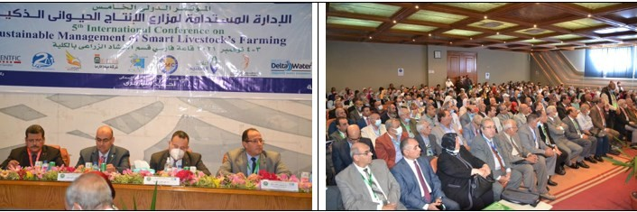
The opening of the international conference organized by the Faculty of Agriculture, Alexandria University, under the title “Sustainable Management of Smart Animal Production Farms.” Its activities continued over two days, during which a group of scientists and specialists discussed ways to reach a common vision and solutions for the development of livestock, poultry and fisheries in Egypt and draw a clear, integrated vision, to confront the challenges that hinder the
advancement of livestock in Egypt.

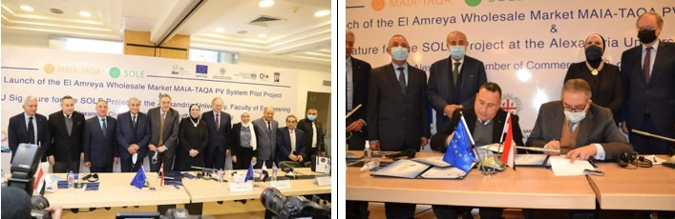
A cooperation agreement between Alexandria University and the Egyptian Chamber of Commerce in Alexandria to establish a solar energy station at the Faculty of Engineering. Under this agreement, the Faculty of Engineering - Alexandria University operates the station with solar energy within the framework of the MAIA-TAQA and SOLE projects funded by the European Union, within the framework of the Mediterranean Basin Cross-Border Cooperation Program EU ENI CBC Med.
It is worth noting that the “SOL” project, funded by the European Union, supports the energy rehabilitation of public
buildings in an effective and economical manner, and ensures the consumption of clean, low-cost energy.
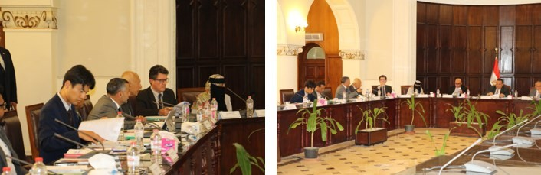
Alexandria University hosted the third meeting of the Steering Committee of the Comprehensive and Sustainable Development of the Tomato Value Chain Project, as the host of the Tomato Value Chain Educational Service Center (TLSC).
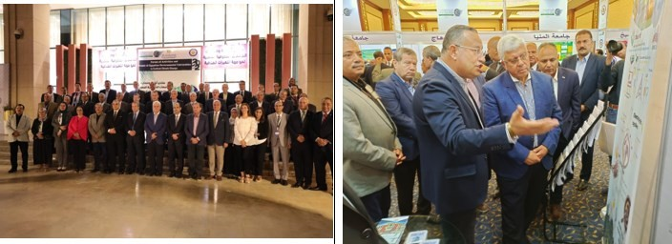
Alexandria University participated in the Egyptian Public Universities Activities and Events Forum to Confront Climate Change 2022, during the period (September 22-23, 2022).

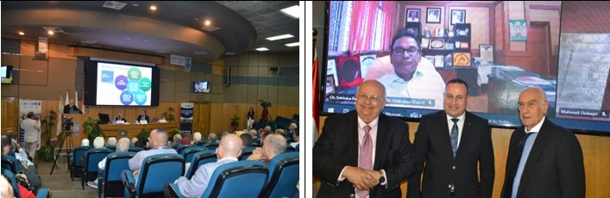
The preparatory webinar for the COP28 Climate Conference, which was organized by the International Committee for the Development of Dry Lands, the Regional Action for Climate Change Foundation in Japan, the “Nizami Ganjavi” International Centre, and the African Organization for Young Leaders, at the Conference Centre of the Faculty of Medicine. The webinar discussed many important topics, including climate change and dry lands, food security, biodiversity, energy and sustainable development, political will and human solidarity needed for change, adaptation,
African youth's view of climate change, the Egyptian perspective on climate change, and funding requirements.
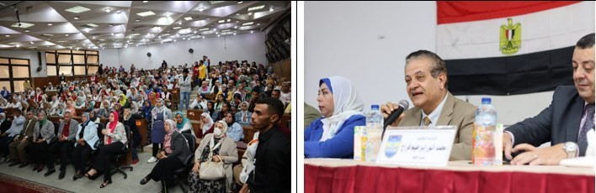
The Faculty of Education hosted the educational symposium on “Community Awareness of the Climate Change Issue, and its Health, Environmental and Economic Impacts”
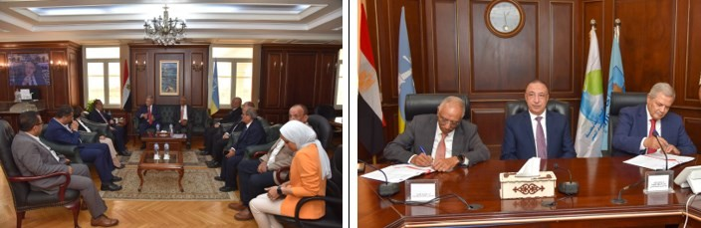
Cooperation protocol between Alexandria University Engineering Centre and the Holding Company for Water and
Wastewater, providing consulting services for Rainwater Management Integrated Strategy Project in Alexandria.

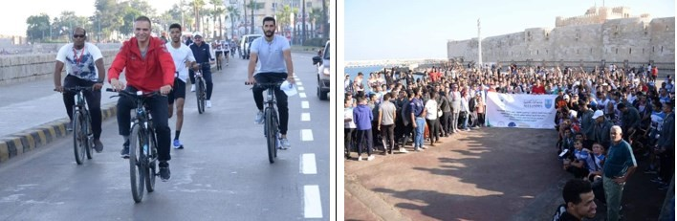
A cycling race and marathon events were launched as part of the Scientific Conference on Climate Change and Sports,
organized by the Faculty of Science and the Faculty of Physical Education in Abu Qir from 27-29 October 2022.
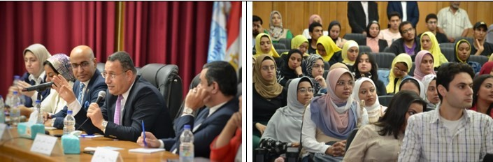
The educational seminar organized by the university, in cooperation with the Youth Coordination of Political Parties and Politicians, under the title "Climate Action Path from Stockholm to Sharm el-Sheikh" and a panel discussion on the national dialogue. The meeting witnessed various discussions among the attendees that dealt with the economic, social and cultural challenges facing the country, which included issues of health, education, infrastructure, environment,
psychological support, high prices, ethical and behavioral phenomena and how to confront them and provide unconventional solutions in light of the available resources.
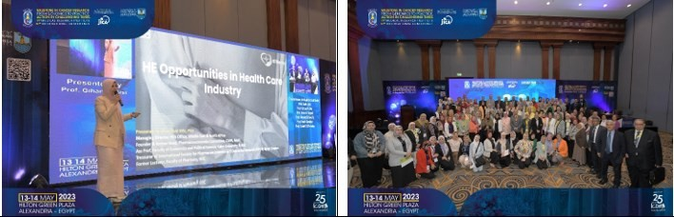
The Medical Research Institute organized its 19th (and 7th international) scientific conference entitled
“Landmarks in Cancer: From Genome Research to Practice in Challenging Times”

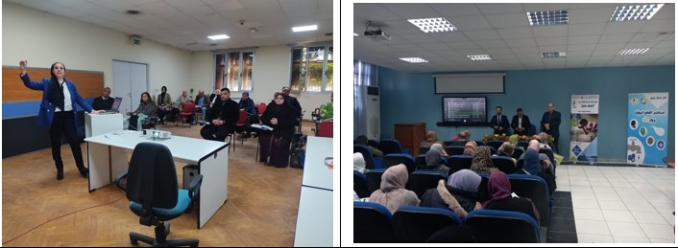
The workshop was held at the Medical Technology Center for Research and Services, which was held on the sidelines of the 8th Annual International Conference on Chemical Pathology under the title Meet the Experts of Hospitals, Clinical Laboratories and Blood Banks Applications of the Pit Falls Accreditation Standards, which was held on  Saturday, February 11, 2023. | The Faculty of Science, Alexandria University, in cooperation with the Alexandria Holding Company for Drinking Water, organized an awareness seminar on water conservation methods on Sunday, March 12, 2023.
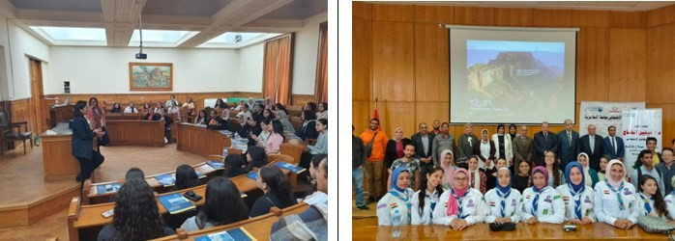
58 students from the German School of St. Charles  Bormes visited the Faculty of Engineering on Sunday, May 7, 2023. | The Social Solidarity Unit at Alexandria University  holds a symposium entitled “Combating Illegal Immigration”
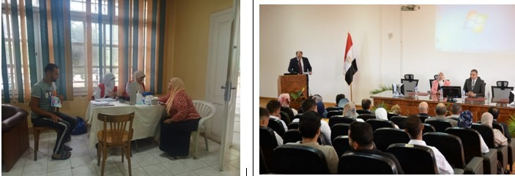
The Faculty of Science, Alexandria University,  received medical teams to provide services for the | The scientific conference on climate change and  sports, which will be held from October 27 to 29,

100 Million Health Initiative, in cooperation with the Alexandria Health Affairs Directorate, on October 1-2, 2023, at the faculty building in  Moharram Bek and Medina. Al-Shatby | 2022, in cooperation between the Faculty of Science and the Faculty of Physical Education for Boys, Alexandria University.
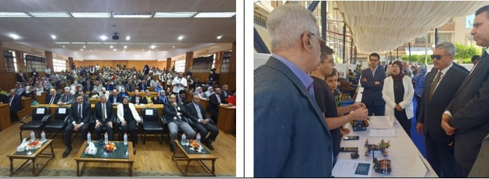
The Tenth Student Conference on Research and Innovation for undergraduate and postgraduate
students and schools, May 13 and 14, 2023, Faculty of Science, Alexandria University.
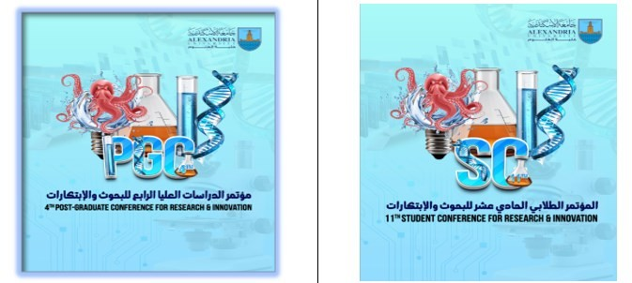
The 11th Student Conference for Research and Innovation for Undergraduate students and the 4th for
Graduate Students was held on April 27-28, 2024 at the Faculty of Science, Alexandria University.
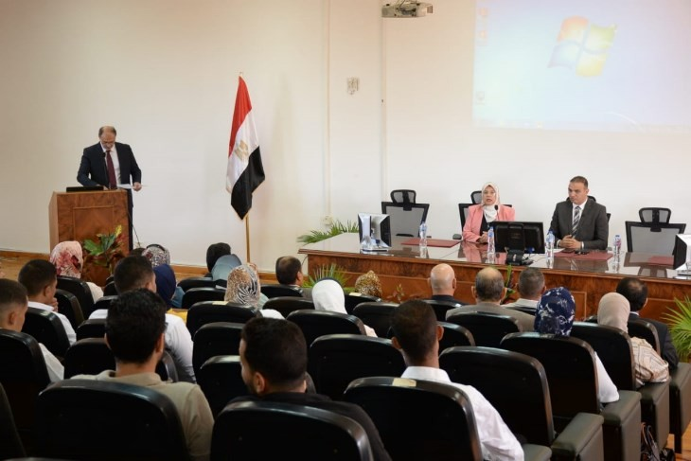

The Scientific Conference on Climate Change and Sports, which was held from October 27 to 29, 2022, in cooperation between the Faculty of Science and the Faculty of Physical Education for
Boys, Alexandria University.
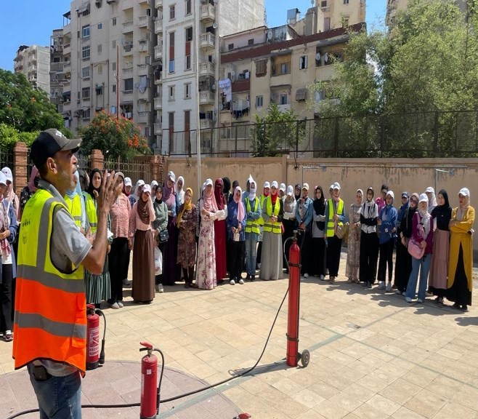
Practical training on how to use fire extinguishers to extinguish fires and the correct extinguishing methods for the college’s occupational safety and health team. August 21, 2023 At the college stadium in Moharram Bey building.
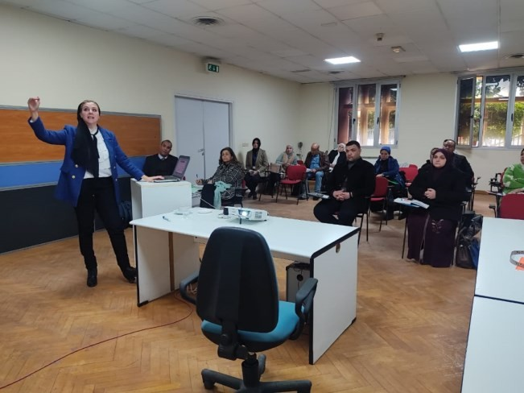
Workshop held at the Medical Technology Center for Research and Services, which was held on the sidelines of the Eighth Annual International Conference on Chemical Pathology, under the title Meet the experts Hospitals clinical laboratories and blood banks accreditation standards
applications pit falls Which was held on Saturday, February 11, 2023.

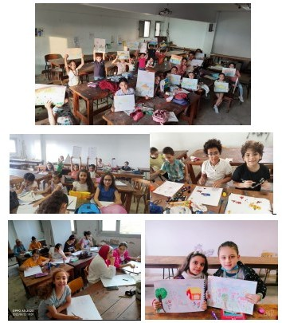
Course "The Little Drawing Studio" for teaching drawing to children June 2024 held by Faculty of Fine Arts.
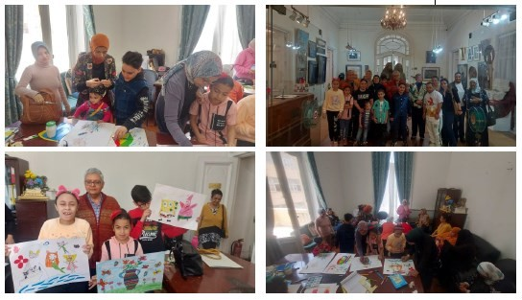

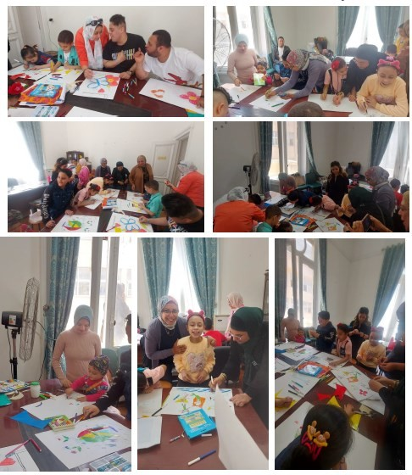
The Faculty of Fine Arts at Alexandria University collaborated with the Art Therapy and Development Foundation to support and empower children with disabilities. They organized a workshop titled "Spring Arts," allowing these children to practice artistic performance and explore their creativity under the supervision of faculty members. The workshop began with a visit to the college museum, where the children learned about its collections from the curator,
Ms. Abeer Shalaby. The children enjoyed the experience and the opportunity for artistic practice at the university.
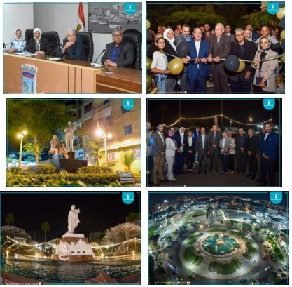
As part of the collaboration between the Faculty of Fine Arts and Alexandria Governorate, a role has been established to participate in the judging committee for a competition organized by Alexandria Governorate among neighborhoods and the city center of Borg Al Arab to develop public squares and gardens within the governorate. This includes attending coordination
meetings related to this initiative.

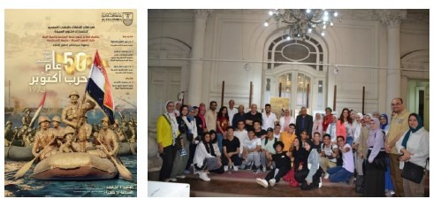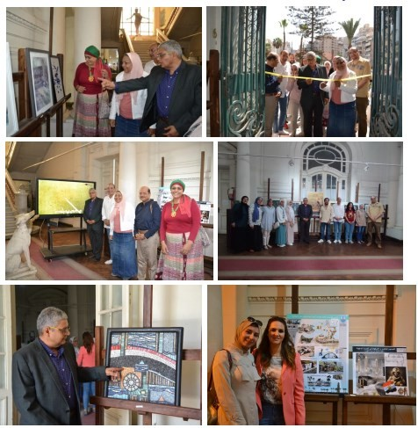
Alexandria University is organizing cultural and awareness-raising events to commemorate the 50th anniversary of the October War, starting from October 1, 2023.

- Art Exhibition: An exhibition titled "50 Years of Egypt's October 1973" will run from October 2 to October 12, 2023, showcasing artworks that highlight the victories of October and Egypt's modern renaissance. It will feature contributions from 31 faculty members in various artistic mediums.
- Cultural Competition: A competition for students will be held in drawing, painting, poetry, short stories, journalistic articles, musical composition, and national anthems, focusing on the heroism of the Egyptian army during the October War. Prizes will be awarded for the top three entries in each category.

Artistic and Aesthetic Collaboration for the Development and Enhancement of the Facility and the Club's Walls. The objective is to aesthetically improve the club and enhance its facilities, providing a proposal for development that meets functional needs. Accordingly, a committee
has been formed, consisting of the following members, to carry out the required tasks.

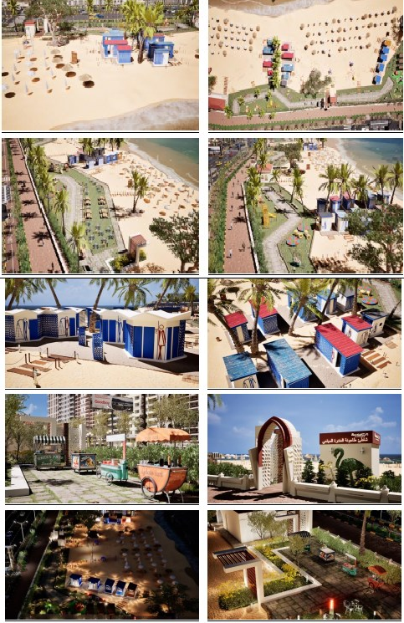
The Project for the Development of the Alexandria Beaches System aims to enhance the quality of services at Alexandria’s beaches through collaboration with the Faculty of Fine Arts at Alexandria University. The project focuses on designing standardized units, such as restrooms, changing rooms, and food kiosks, using weather- resistant materials. Key objectives include standardizing the external appearance of the units, identifying suitable locations based on beach characteristics and size, determining the number of units according to beach area and visitor density, ensuring materials used are appropriate for coastal conditions, and considering the project’s visual
identity.Top of FormBottom of Form
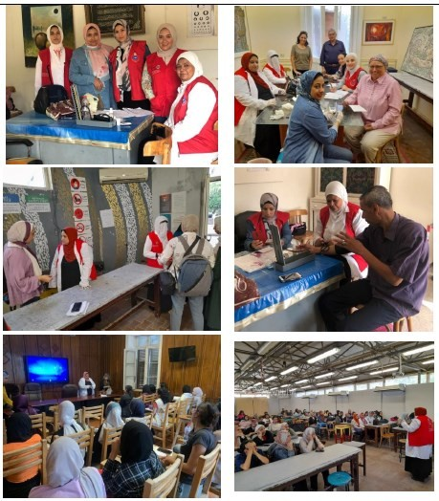
The Faculty of Fine Arts is collaborating with the Eastern and Central Medical Zones' Media and Population Education Departments to implement the "100 Days of Health" initiative by the President of the Republic. This initiative focuses on women's health, early detection of chronic diseases, kidney
disorders, cancers, and COVID-19 vaccinations. Events were organized within October, 2023.

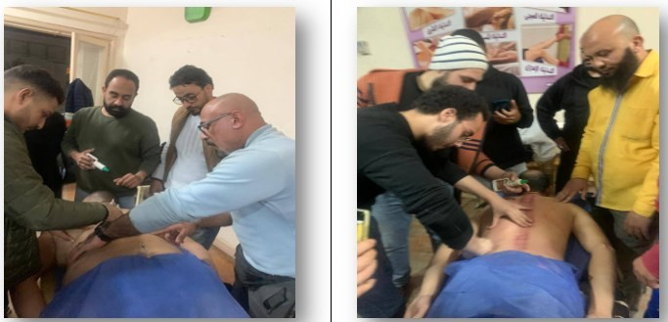
Cupping Therapy and Its Applications in Sports Activity - March 2, 2024, held by faculty of sport
Education for Girls
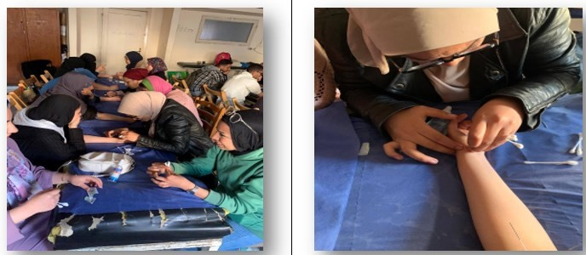
Acupuncture and Its Applications in Sports Activity - March 7, 2024, held by faculty of sport Education for
Girls.
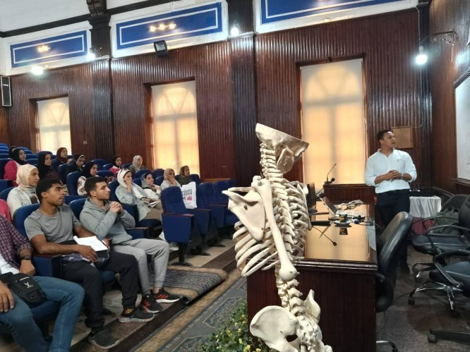
Functional Anatomy, Massage, and Cupping Therapy - May 10, 2024, held by faculty of sport Education
for Girls.

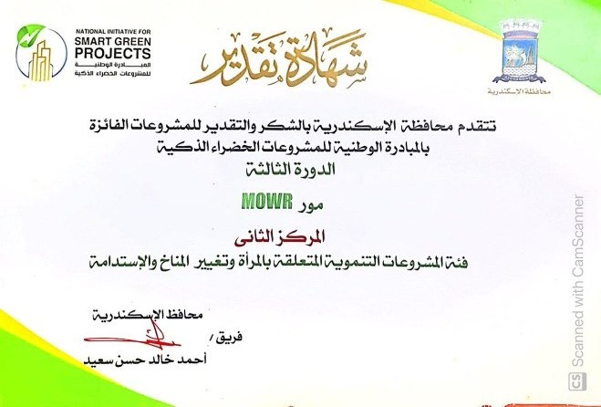
Prof. Dr. Doaa Ahmed Gharib, a professor in the Biochemistry Department at the Faculty of Science, Alexandria University, was awarded second place in the category of developmental projects related to women, climate change, and sustainability at the Alexandria Governorate level, as part of the "Third
Round" of the National Initiative for Smart Green Projects.
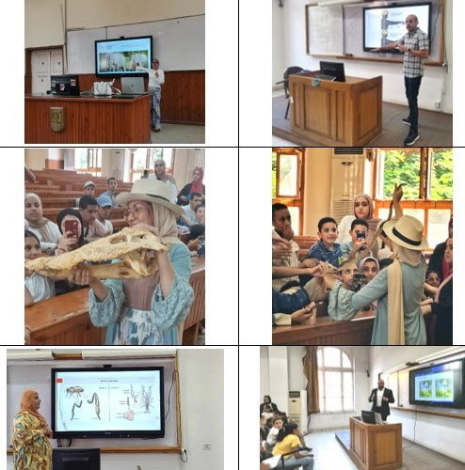

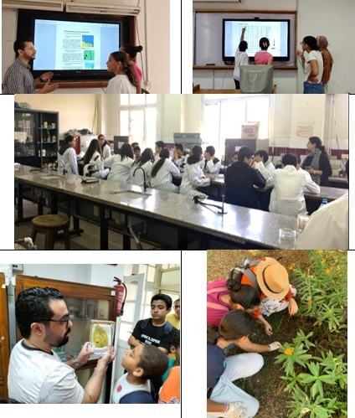
As part of the summer activity plan at the Faculty of Science, Alexandria University, in order to raise awareness among school students in Alexandria, a series of scientific lectures covering various fields was organized to prepare students from the Educational Exploratory Center under the Ministry of Education. The lectures were held weekly throughout August 2024, featuring a variety of presentations by students
from the faculty academic staff members.
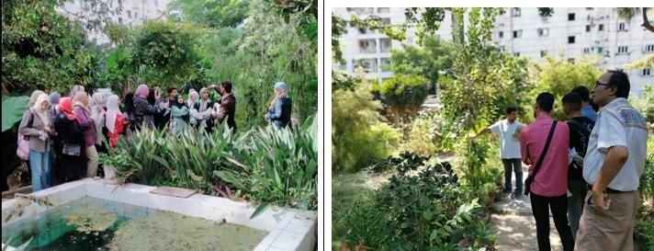

Students from various schools in Alexandria, as well as public and private universities across Egypt, are welcomed at the botanical garden (ALEX) of the Faculty of Science in Moharram Bek. This visits aim to introduce them to economically important, endemic, and rare plant species, raising their awareness about plant and floral diversity and the importance of conserving endangered plant species. This effort is part of the university’s plan to serve the community, and achieve the 17th goal of sustainable
development (partnership for goals).
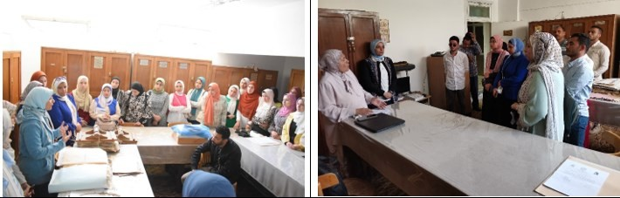
Students from various schools in Alexandria, as well as public and private universities across Egypt, are welcomed at the Herbarium of the Faculty of Science at Chattby building. These visits aim to introduce them to the herbarium’s role, which is essential for preserving plant specimens and aiding in research, education, and conservation efforts. This effort is part of the university’s plan to serve the community
and achieve the 17th goal of sustainable development (partnership for goals).
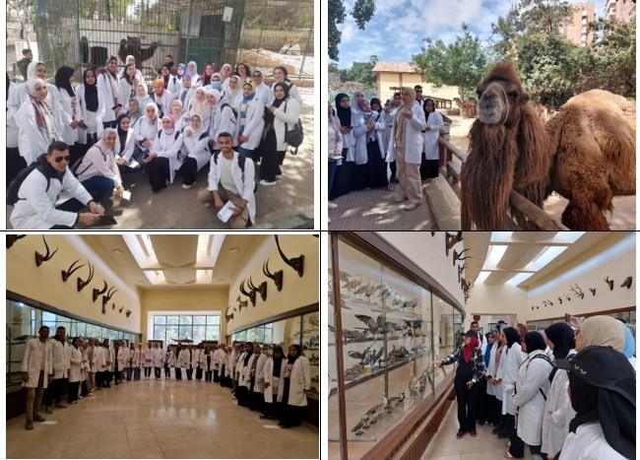
The Zoology Department at the Faculty of Science, Alexandria University, organized a field trip to the Zoological park of Alexandria. The visit aimed to highlight the practical and applied aspects of what has been studied in the theoretical lectures of the Animal Ecology course for third-year students in the department. The students actively participated by observing and commenting on the structural adaptations and feeding behaviours of the mammals residing in the zoo and the importance of these
adaptations in the lives of these creatures (March 2024).

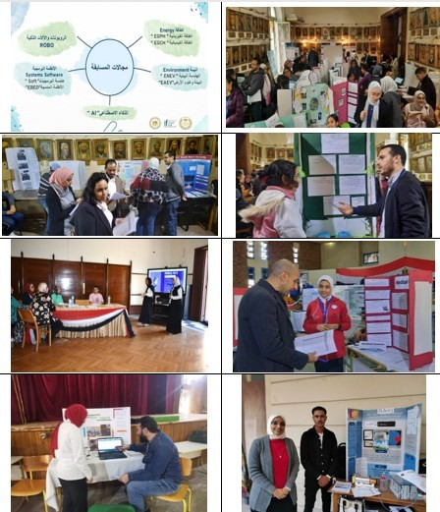
Several faculty members from Alexandria University are participating in judging school students’ competitions. Judging school students’ projects submitted for participation in scientific competitions organized by the Ministry of Education and international competitions such as the ISEF (International Science and Engineering Fair). The
students’ projects cover various topics, including environmental problems, technology, artificial intelligence, and
medical sciences.
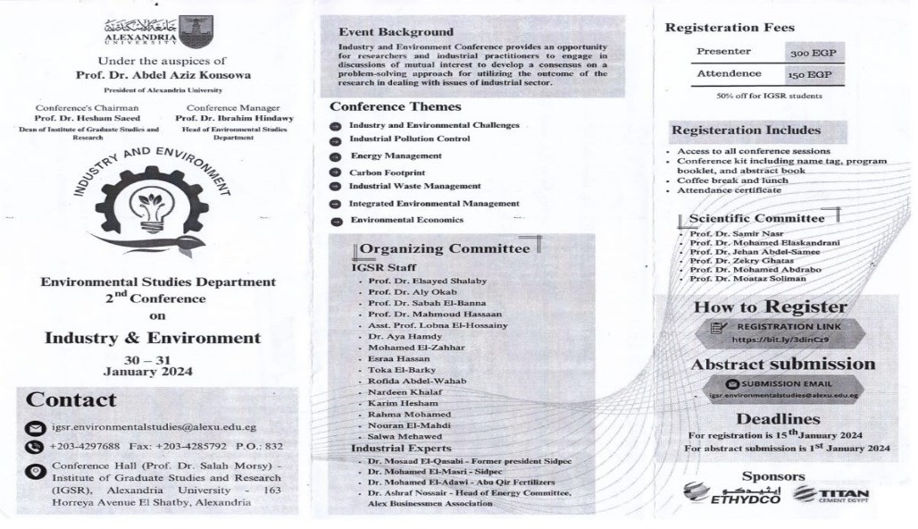
Industry and Environment Conference held by Institute of Graduate Studies and Research,
Alexandria University (30-31 January 2024)

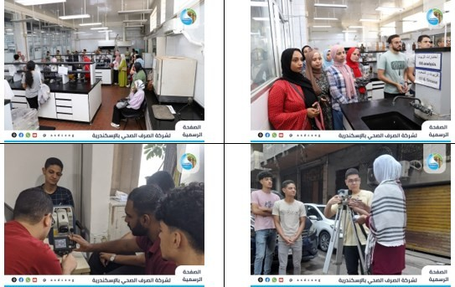
Raising awareness among Alexandria University students about wastewater treatment was achieved through summer training activities conducted at Alexandria Sewerage for students from various faculties, including Science, Engineering (Civil, Mechanical, and Mechatronics), Commerce, Arts (Surveying, Mapping, and GIS), and Fine Arts
(Architecture), September 2024.
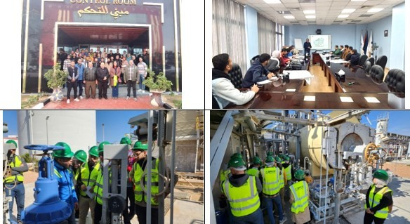
The Center of Excellence for Water at Alexandria University is organizing a training program for scholarship students in collaboration with EPROM Company. This initiative aims to equip students with practical skills in water management including training courses about Water Treatment for Industrial Applications, and Wastewater Plant Operations and Troubleshooting, ensuring they are well-prepared for the business sector and aligned with labor
market requirements (March, 2024).

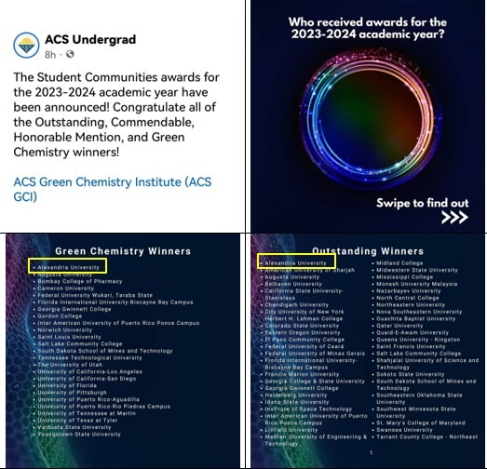
The ACS Green Chemistry Institute (ACS GCI) has announced the Student Communities awards for the 2023-2024 academic year, recognizing Alexandria University as the top winner in the Outstanding, Commendable, Honorable
Mention, and Green Chemistry categories.

Conferences and Symposia (2023-2024) Alexandria University, Egypt
NO | College/organizer | Event Name | Place | Duration
 |  |  |  | From | To
1 | Faculty of Arts | Symposium on the | Faculty | 17/01/2023 | 18/01/2023
 |  | maritime cultural heritage
 |  | of the Red Sea
2 |  | Symposium on “National | Faculty | 20/02/2023
 |  | Discourse in Light of
 |  | International Challenges
 |  | and Changes”
3 |  | Seminar: “The Impact of | Faculty | 27/02/2023
 |  | the Russian and Ukrainian
 |  | War on National Security”
4 |  | “Environment and | Faculty | 06/03/2023
 |  | Society: The Role of
 |  | Women between Reality
 |  | and Aspirations”
 |  | Symposium
5 |  | Seminar on “Optimal Use | Faculty | 22/02/2023
 |  | of Social Networks”
6 |  | Workshop “In | Faculty | 28/02/2023
 |  | cooperation with the
 |  | Educational Innovations
 |  | Unit”

7 |  | Free books gallery | Faculty | 19/02/2023 | 21/02/2023
8 |  | Symposium on “Climate | Faculty | 20/02/2023
 |  | Change and its Impact on
 |  | Egypt”
9 |  | Clothes exhibition for | Faculty | 13/02/2023 | 16/02/2023
 |  | college students
10 |  | Symposium on “The Role | Faculty | 01/03/2023
 |  | of Innovation in
 |  | Developing Various
 |  | Aspects of Life”
11 |  | Workshop on “3D imaging | Faculty | 18/03/2023 | 22/03/2023
 |  | and its digital applications
 |  | in the field of
 |  | archaeology”
12 |  | “Drama and Society” | Faculty | 20/03/2023
 |  | Symposium
13 |  | Symposium on “Egyptian | Capacity | 06/03/2023
 |  | Women’s Issues between | Development
 |  | Reality and Aspirations” | Centre
14 |  | Campaign (It will not be | Faculty | 11/03/2023
 |  | lost)
15 |  | “Positive Psychology and | Faculty | 08/03/2023
 |  | Arab Research”
 |  | Symposium
16 |  | Charity exhibition for | Faculty | 14/03/2023 | 16/03/2023
 |  | Kayan Association
17 |  | Conference on “Using | Faculty | 26/02/2023
 |  | Media in Curricula in
 |  | Egyptian Universities”
18 |  | Symposium on “The Role | Capacity | 10/05/2023
 |  | of Cultural Platforms in | Development
 |  | Developing Youth | Centre
 |  | Awareness”
19 |  | Seminar: “How to Apply | Faculty | 29/04/2023
 |  | for Grants”
20 |  | Scientific Seminar “The | Faculty | 10/06/2023
 |  | Mediterranean
 |  | Environment:
 |  | Opportunities and
 |  | Challenges”
21 |  | Conference “Alexandrian | Faculty | 09/05/2023
 |  | Heritage and its
 |  | Connection to What
 |  | Before and After”
22 |  | Theater Department | Alexandria | 10/07/2023 | 20/07/2023
 |  | Festival for specialized | Library
 |  | departments and
 |  | institutes
23 |  | A cultural salon for | Faculty | 03/05/2023
 |  | Alexandria University and
 |  | a cultural salon for the
 |  | Faculty of Arts
24 |  | Workshop on leather | Faculty | 04-02-2024 | 20-02-2024
 |  | crafting

25 |  | Free book exhibition | Faculty | 01-02-2024 | 01-03-2024
26 |  | Two-day introductory | Faculty | 03-03-2024 | 04-03-2024
 |  | workshop on
 |  | documentary films
27 |  | Lecture titled “Using AI | Faculty | 18-02-2024
 |  | applications in libraries
 |  | and information”
28 |  | Charity market | Faculty | 04-03-2024 | 06-03-2024
29 |  | Festival titled “The | Bibliotheca | 01-03-2024 | 07-03-2024
 |  | Theater Department | Alexandrina
 |  | Festival for Specialized
 |  | Departments and
 |  | Institutes”
30 |  | Workshop titled “How to | Faculty | 13-03-2024
 |  | use the electronic paper
 |  | edition of the Arabic
 |  | translation of MARC 21”
31 |  | Lecture titled “The | Faculty | 04-03-2024
 |  | East/Western encounter
 |  | since the Middle Ages
 |  | through”
32 |  | Cultural salon on the | Faculty | 25-02-2024
 |  | occasion of World Short
 |  | Story Day
33 |  | Cultural Ramadan night at | Faculty | 31-03-2024
 |  | the Library Department
34 |  | Judging meeting for the | Faculty | 05-03-2024
 |  | best research competition
 |  | for Library Department
 |  | students
35 |  | Open meeting with | Faculty | 14-04-2024
 |  | students with special
 |  | needs in the department
36 |  | Roundtable titled | Faculty | 21-04-2024
 |  | “Translation in the digital
 |  | age: Challenges and
 |  | prospects”
37 |  | Lecture titled | Faculty | 02-03-2024
 |  | “Regulations for the work
 |  | of technical bodies
 |  | assisting various judicial
 |  | authorities”
38 |  | Free book exhibition | Faculty | 01-02-2024 | 01-03-2024
39 |  | Seminar titled “The role | Faculty | 27-03-2024
 |  | of youth in facing
 |  | contemporary challenges”
40 |  | Seminar titled “Egypt’s | Faculty | 07-05-2024
 |  | efforts to combat illegal
 |  | immigration and human
 |  | trafficking and raise
 |  | awareness of its dangers”

41 |  | Introductory workshop on documentary films | Faculty | 03-03-2024 | 04-03-2024
42 |  | Rescheduling of the leather crafting workshop | Faculty | 04-02-2024 | 20-02-2024
43 |  | One-day workshop titled “For men only - Join us to protect her” | Faculty | 21-03-2024
44 |  | One-day workshop for university city girls and workers titled “Yourself is  a trust - Defend it” | University Dormitories | 19-03-2024
45 |  | Workshop titled “Program and course description” | Faculty | 06-04-2024
46 |  | Workshop titled “How to use the electronic and paper edition of the Arabic translation of  MARC 21” | Faculty | 13-03-2024
47 |  | Seminar “Philosophy as a way of life” | Faculty | 04-05-2024
48 |  | Seminar “The role of intellectual property in preserving and developing intangible  cultural heritage” | Faculty | 29-04-2024
49 |  | Introductory seminar on grants and opportunities offered by the Fulbright  Commission | Online | 15-05-2024
50 |  | the agricultural workshop to learn about sustainable solutions to avoid overconsumption of  natural materials | Faculty | 03-07-2024
51 |  | Seminar titled “The current state of philosophical studies in the Arab and Western  worlds” | Faculty | 20-08-2024
52 |  | Lecture titled “Egyptian-  Chinese historical  relations” | Faculty | 01-08-2024
53 |  | Seminar titled “Concept of occupational safety and health and its  objectives” | Faculty | 08-09-2024
54 |  | Seminar titled “The current state of philosophical studies in the Arab and Western  worlds” | Faculty | 20-08-2024
55 | Faculty of education | Charitable clothing exhibition, We Are Al Khair Foundation | Faculty | 25/02/2023 | 05/03/2023
56 |  | German School  Conference | Faculty | 25/02/2023

57 |  | Emerging Women Writers Conference Form The  Margins | Faculty | 10/03/2023 | 11/03/2023
58 |  | Book Fair | Faculty
59 |  | Conference “Digitizing the Curriculum and Competencies of the  Future” | Faculty | 02/09/2023
60 |  | Celebration of “Martyr’s Day” | Faculty | 10-03-2024
61 |  | Alexandria University’s  First Book Fair | Faculty | 21-02-2042 | 30-03-2024
62 |  | Subsidized Fair for Students, Employees, and Workers at the  Humanities Complex | Faculty | 20-02-2024 | 30-03-2024
63 |  | “Welcome Ramadan” and  Siwa Products Fair | Faculty | 21-02-2024 | 30-03-2024
64 |  | Secondary Conference of the German School | Faculty | 26-02-2024
65 |  | Participatory Workshop with Alexandria  Governorate | Faculty | 11-01-2024
66 |  | Education Policies Forum  titled “Issues in Educational Policy” | Faculty | 20-04-2024
67 |  | Seminar on “Ways to  Reduce Illegal  Immigration” | Faculty | 29-04-2024
68 |  | Conference titled  “Innovation Management and Entrepreneurship in Educational Institutions:  Future Visions” | Faculty | 27-07-2024
69 | Faculty of education quality | National Dialogue  Symposium | Faculty | 30/03/2023
70 |  | The first meeting for fine art | Faculty | 26/09/2023
71 |  | International Conference titled “Innovation in Quality Education and Artificial Intelligence Challenges (Visions and  Proposals)” | Faculty of Economics | 14-02-2024 | 15-02-2024
72 |  | Kindergarten Level Two Graduation Ceremony | Faculty | 03-05-2024
73 |  | Charity Market of the Association | Faculty | 05-03-2024 | 09-03-2024
74 |  | Art Therapy Workshop | Faculty | 16-02-2024
75 | Faculty of Agriculture | Symposium on “Home  Economics and Climate  Change” | Faculty | 08/03/2023
76 |  | Exhibition of agricultural and industrial products | Faculty | 22/02/2023 | 23/02/2023

77 |  | Workshop on “Estimation of Sugars in Cotton” | Faculty | 12/03/2023 | 13/03/2023
78 |  | A permanent exhibition throughout the month of  Ramadan | Faculty | 20/03/2023 | 20/04/2023
79 |  | Symposium on “The Virtues of the Holy Month of Ramadan and Commemorating the  October Victories” | Faculty | 12/04/2023
80 |  | “Awareness Leaders  Ambassadors” workshop | Faculty | 06/05/2023
81 |  | Workshop on the university Agrochemical | Alexandria Library | 30/04/2023
82 |  | “Twelfth Employment”  Forum | Faculty | 02/05/2023
83 |  | Training course for agricultural engineers working in the pesticide  trade | Faculty | 28/01/2023 | 01/02/2023
84 |  | “Antimicrobial Project”  Workshop | Faculty | 28/05/2023
85 |  | Training course “Developing the Romanian cheese industry to compete in  global markets” | Faculty | 21/05/2023 | 25/05/2023
86 |  | Workshop on “Chemical and microbiological analysis of dairy products according to ISO  methods.” | Faculty | 20/01/2023
87 |  | The first forum for entrepreneurship and  innovations | Faculty | 21/06/2023
88 |  | Americana Company seminar to introduce the  company’s activities | Faculty | 20/06/2023
89 |  | Workshop on “Nanotechnology to Support Sustainable Development of  Agricultural Production” | Faculty | 27/07/2023
90 |  | Summer Science Club for Students | Faculty | 15/07/2023 | 15/08/2023
91 |  | Training courses to raise the efficiency and skills of  undergraduate students | Faculty | 15/07/2023 | 15/08/2023
92 |  | “Food Safety and Quality”  Workshop | Faculty | 09/07/2023 | 11/07/2023
93 |  | Workshop on “Basic Requirements for the Food Safety System” | Faculty | 16/07/2023 | 20/07/2023
94 |  | Training courses to raise the efficiency and skills of  undergraduate students | Faculty | 15/07/2023

95 |  | Bioinformatics workshop, first level | Faculty | 01/08/2023
96 |  | Molecular biology techniques workshop -  basics | Faculty | 06/08/2023
97 |  | Molecular biology techniques workshop -  advanced level | Faculty | 20/08/2023
98 |  | The first scientific forum for insect students in the Arab Republic of Egypt | Faculty | 10/10/2023
99 |  | The first Genetics and Biotechnology Youth  Forum | Faculty | 29/08/2023
100 |  | Integration workshop between the university and the animal  production industry | Faculty | 24/09/2023
101 |  | Workshop on “Arduino  Basics and Its  Applications.” | Faculty | 31/08/2023
102 |  | Workshop on “Estimation of Sugars in Cotton” | Faculty | 18/09/2023
103 |  | Symposium on the impact of climate change on modern trends used in the management of plant  diseases | Faculty | 13/09/2023
104 |  | Symposium on “Home  Economics and Climate  Change” | Faculty | 08/03/2023
105 |  | Exhibition of agricultural and industrial products | Faculty | 22/02/2023 | 23/02/2023
106 |  | Workshop on “Estimation  of Sugars in Cotton” | Faculty | 12/03/2023 | 14/03/2023
107 |  | Exhibition throughout the month of Ramadan | Faculty | 20/3/203 | 20/04/2023
108 |  | Annual Celebration for the Distribution of Dream Company Awards to Encourage Scientific Research in Egypt for  2024 | Faculty | 22-04-2024
109 |  | Awareness Program for College Employees to Spread Insurance Awareness and Financial Planning among  Employees and Workers | Faculty | 11-02-2024 | 25-02-2024
110 |  | Online Technology Awareness Ambassadors  Program | Faculty | 25-04-2024 | 26-04-2024
111 |  | 13th Job Fair | Faculty | 17-04-2024
112 |  | Seminar titled  “Nanotechnology and Its | Faculty | 22-02-2024

Applications in Home
Economics”
113 |  | Seminar titled “Organic Farming and the Future of Egypt to Increase  Agricultural Yields” | Faculty | 04-03-2024
114 |  | Seminar titled “Future Vision for Post- Graduation and Labor Market Needs in the  Agricultural Field” | Faculty | 24-04-2024
115 |  | Workshop titled “Job Search Club in Alexandria Governorate” | Faculty | 18-02-2024 | 28-02-2024
116 |  | Workshop titled  “Integration between the  University and Animal  Production Industry” | Faculty | 16-05-2024
117 |  | Several Workshops titled “High-Level Administrative and  Executive Leadership” | Faculty | 17-02-2024 | 23-04-2024
118 |  | Workshop titled “High- Level Administrative and  Executive Leadership” | Faculty | 11-05-2024 | 25-06-2024
119 |  | Workshop titled “Bed Bugs Cause Concern” | Faculty | 24-04-2024
120 |  | Workshop titled “Job  Search Club in Alexandria  Governorate” | Faculty | 18-02-2024 | 28-02-2024
121 |  | Forum to Introduce the Egyptian Cheese and Dairy Products Festival | Faculty | 18-07-2024
122 |  | Holding (5) Training Courses for the Francophone Agency Award Project Funded by the University Agency  titled “The Classroom Turns into the Labor Market: Developing Agricultural  Entrepreneurship Skills” | Faculty | 11-08-2024 | 08-10-2024
123 |  | Holding the “Second  Youth Genetics and  Biotechnology Forum” | Faculty | 28-08-2024
124 | Faculty of Business | Workshop on  “Sustainable Blue Economy Issues in the Mediterranean Basin  Countries” | Faculty | 03/01/2023
125 |  | Celebration "Happy Children's Day" | Faculty | 17/03/2023
126 |  | College of Business  Charity Exhibition | Faculty | 04/03/2023 | 31/03/2023
127 |  | International Conference  “The Impact of Global | Faculty | 20/07/2023 | 21/07/2023

Changes on Business
Sustainability”
128 |  | CMA certification training  program | Faculty | 16/05/2023
129 |  | "Entrepreneurship" seminar | Faculty | 14/05/2023
130 |  | Seminar" Teaching Applications in Recreational Sports Activities in Field Training  Institutions" | Faculty | 26/04/2022
131 |  | Holding the College  Charity Fair | Faculty | 10-02-2024 | 10-03-2024
132 |  | Organizing an Introductory Seminar titled “What After Graduation? Be  Distinguished” | Faculty | 01-02-2024
133 |  | Holding an Educational Seminar titled  “Management by Values  and the Success of the  Industrial System” | Faculty | 25-02-2024
134 |  | Holding an Educational Seminar titled “How to Write a CV and Pass Personal Interviews in the  Banking Field” | Faculty | 07-03-2024
135 |  | Holding a Grand Olympiad Celebration to Promote  Entrepreneurship at the University | Faculty | 11-07-2024
136 |  | 21st International Conference titled “Global Challenges and Achieving  Business Sustainability” | Faculty | 13-07-2024
137 |  | Workshop titled  “Proposals for Developing  the Real Estate Tax Law” | Faculty | 05-10-2024
138 | College of Physical Education for Boys | Scientific Forum "Doping in the Sports Field" | Faculty | 09/03/2023
139 |  | Symposium on “Violence  among youth and its  impact on society” | Faculty | 02/04/2023
140 |  | A sports day for the employees of the  Montazah Second District | Faculty | 11/08/2023
141 |  | Seminars for the fourth group during the compulsory camp | Faculty | 08/07/2023 | 22/03/2023
142 |  | Seminar titled “The Impact of Fasting on Moral Values and Social  Responsibility” | Faculty | 21-03-2024
143 |  | Recreational Sports Day  and Iftar for 200 Children | Faculty | 04-04-2024

 |  | and Their Families with Special Needs
144 |  | Seminar on “Hepatitis  Viruses and Liver  Diseases” | Faculty | 28-02-2024
145 |  | Seminar on “Supporting  Youth-Friendly Health  Services” | Faculty | 05-03-2024
146 |  | Seminar on “Addiction and Drugs: A Warning Bell” | Faculty | 19-03-2024
147 |  | Seminar on “Psychological  Changes in Adolescents” | Faculty | 26-03-2024
148 | College of Physical Education for girls | Symposium on “Methods of Standardization of Specific Means in  Training” | Faculty | 15/03/2023
149 |  | Symposium on “Recreation and Psychological Stress” | Faculty | 07/03/2023
150 |  | Symposium on “Digital  Transformation Strategy  in Physical Education” | Faculty | 09/03/2023
151 |  | “Social Media Addiction”  Seminar | Faculty | 12/03/2023
152 |  | Environmental program  "Speak Green" | Faculty | 20/03/2023
153 |  | Symposium on “Principles  of Psychological Dealing  with the Gifted” | Faculty | 14/03/2023
154 |  | “Let’s Live Without  Diseases” Symposium | Faculty | 03/05/2023
155 |  | Symposium on “Spine Injuries Diagnosis and Treatment Methods” | Faculty | 29/04/2023
156 |  | Symposium on “Early Marriage and the Population Issue” | Faculty | 30/04/2023
157 |  | Seminar “National  Dialogue Forum under the  slogan What Youth Think” | Faculty | 23/05/2023
158 |  | College employment forum | Engineers Syndicate | 20/05/2023
159 |  | Symposium on “Naval Forces Championships between the War of Attrition and the October  War” | Faculty | 18/05/2023
160 |  | Charity Fair for the Blind to Showcase Their Products to Students and  Employees | Faculty | 25-02-2024
161 |  | Badminton Festival | Faculty | 26-01-2024
162 |  | Awareness Seminar titled  “Practical Applications for | Faculty | 21-02-2024

Recovery After Training and Competitive Sessions
in Sports”
163 |  | Awareness Seminar titled  “Adolescence” | Faculty | 04-03-2024
164 |  | Awareness Seminar titled  “Positive Parenting” | Faculty | 13-03-2024
165 |  | Awareness Seminar titled  “Proper Nutrition and First Aid” | Faculty | 26-02-2024
166 |  | Awareness Seminar titled “Modern Technological Techniques in Education and Their Importance in  Sports” | Faculty | 23-04-2024
167 |  | Awareness Seminar titled “The Role of Kinetic Education in Developing Skills for People with  Disabilities” | Faculty | 23-03-2024
168 |  | Awareness Seminar titled  “Statistics and Its Applications in Sports” | Faculty | 20-04-2024
169 |  | Awareness Seminar titled “Employing Modern Technologies in Sports  Sciences” | Faculty | 24-04-2024
170 | Faculty of Science | High Energy Physics  Simulation Course | Faculty | 04/02/2023 | 07/02/2023
171 |  | Charity exhibition | Faculty | 04/03/2023 | 06/03/2023
172 |  | An awareness seminar and an exhibition to introduce how to  rationalize water | Faculty | 12/03/2023
173 |  | Teaching Excellence in Physics Education workshop | Faculty | 19/03/2023
174 |  | Neuroinfammatory  Mechanisms Underlying | Faculty | 08/03/2023
175 |  | Orphan's Day celebration | Faculty | 05/05/2023
176 |  | Course “Safety requirements for working at heights and safety in  using scaffolds” | Faculty | 20/05/2023
177 |  | world Quantum Day 2023  - Egypt | Online | 14/04/2023
178 |  | Celebrating the Children's Festival "Orphan's Day" | Faculty | 05/05/2023
179 |  | Lecture: “Roadmap for a  better future” | Faculty | 06/05/2023
180 |  | The 10th Student Research and Innovation Conference and the 3rd  Postgraduate Conference | Faculty | 13/05/2023 | 14/05/2023

181 |  | Training course "First Aid" | Faculty | 27/07/2023
182 |  | Mathematics workshop  for postgraduate students | Faculty | 06-02-2024 | 08-02-2024
183 |  | The 11th employment forum | Faculty | 10-02-2024
184 |  | Lecture “How Can Fresh  Graduates Be Candidates  for Oil and Gas” | Faculty | 16-03-2024
185 |  | The 11th student conference on research and innovations and the 4th postgraduate  conference | Faculty | 27-04-2024 | 28-04-2024
186 |  | Workshop on the basics of occupational safety and health to provide a safe  working environment | Faculty | 30-04-2024
187 |  | Lecture “How Graduates Prepare Themselves for a Safety Career” | Faculty | 06-04-2024
188 |  | Organizing occupational safety and health activities for the academic year  2023/2024 | Faculty | 08-07-2024 | 29-07-2024
189 |  | Organizing a series of special activities and workshops by the American Chemical Society - Egypt (Egyptian  Chapter) | Faculty | 24-07-2024 | 07-08-2024
190 |  | Introduction to Computer Basics | Faculty | Jul-23
191 |  | German Course | Faculty | Jul-24
192 |  | “ICDL” | Faculty | Aug-23
193 |  | “Computer Applications” | Faculty | Sep-23
194 |  | “ICDL” | Faculty | Oct-23
195 |  | German Course | Faculty | Nov-23
196 |  | “Computer Applications” | Faculty | Dec-23
197 |  | “ICDL” | Faculty | Dec-24
198 |  | “Teacher Preparation” | Faculty | Jan-24
199 |  | Introduction to Computer Basics | Faculty | Feb-24
200 |  | “ICDL” | Faculty | Feb-25
201 |  | Introduction to Computer  Basics | Faculty | Mar-24
202 |  | “ICDL” | Faculty | Mar-25

203 |  | Introduction to Computer Basics | Faculty | Mar-26
204 |  | “Computer Applications” | Faculty | Apr-24
205 |  | German Course | Faculty | May-24
206 |  | “Computer Applications” | Faculty | May-25
207 |  | German Course | Faculty | Jun-24
208 |  | Introduction to Computer Basics | Faculty | Jun-25
209 |  | “ICDL” | Faculty | 07-Sep-23
210 |  | Unit of Electron Microscope and Scientific  Research Service | Faculty | 31-Oct-23
211 |  | Modern Methods for Identifying Chemical Compounds Using Available Devices in the  Electron Microscope Unit | Faculty | January 30-31,  2024
212 |  | Basic Aspects of the  Cosmetics Industry | Faculty | February 6-7,  2024
213 |  | Skin Care Products and Perfume Industry | Faculty | February 20-  22, 2024
214 |  | Structure and Uses of Transmission and Scanning Electron Microscopes in the Ultra-Structure Study of Dental and Oral Para-  Dental Tissues | Faculty | 09-Jul-23
215 |  | Special Units at the Faculty of Science, Alexandria  University | Faculty | September 9-  27, 2023
216 |  | Research Intelligence | Faculty | November 11-  19, 2023
217 |  | Marine Pollution | Faculty | 02-Dec-23
218 |  | Abu Qir Fertilizers Company: Objectives and Opportunities | Faculty | 16-Dec-23
219 |  | Science, Technology, and  Innovation Map in Egypt | Faculty | 23-Dec-23
220 |  | How Can Fresh Graduates be Candidates for the Oil and Gas Industry | Faculty | 16-Mar-24
221 |  | How Can Fresh Graduates be Candidates for the Oil  and Gas Industry (Part 2) | Faculty | 06-Apr-24
222 |  | How Graduates Prepare Themselves for a Safety  Career | Faculty | 30-Apr-24
223 |  | Dealing with the Exam Paper in Exam Committees and Important Tips to Avoid Mistakes | Faculty | 01-May-24

224 |  | How to Use Fire Extinguishers in  Firefighting | Faculty | 07-May-24
225 |  | Occupational Safety and Health and Environmental Protection | Faculty | 09-May-24
226 |  | How to Safely Evacuate in  Emergencies | Faculty | 22-May-24
227 |  | Guidance Tips for Observers on Exam Rules in Light of the Requirements of the Electronic Correction  System | Faculty | 06-Apr-24
228 |  | How Can Fresh Graduates be Candidates for the Oil and Gas Industry | Faculty | From September 17,  2023 to  September 28,  2023
229 |  | Training Members of the Committee at the Labor Cultural Institution Affiliated with the Ministry  of Manpower | Faculty | 30-Apr-24
230 |  | Using Types of Fire Extinguishers Available at the College (for Laboratory Technicians, Storekeepers, and Auxiliary Service  Workers) | Faculty | 09-May-24
231 |  | How to Safely Evacuate in Emergencies for Firefighting and  Evacuation Teams | Faculty | Periodically
232 |  | Five Members of the Occupational Safety and Health Committee Trained  on Firefighting | Faculty | 23-Apr-24
233 |  | Lecture on Mental Health | Faculty | 24-Apr-24
234 |  | Lecture on Crisis Management and Problem  Solving | Faculty | 31-Jul-23
235 |  | Lecture on Water, Human Health, and Sustainability | Faculty | 07-Aug-23
236 |  | Lecture on Occupational Safety and Health  Legislation | Faculty | 14-Aug-23
237 |  | Securing the Work Environment from Fires and Electrical Hazards | Faculty | 31-Aug-23
238 |  | Occupational Safety and  Health Requirements and Emergency Plan | Faculty | 27-Jul-23
239 |  | First Aid | Faculty | 31-Jul-23

240 |  | Water, Human Health, and Sustainability | Faculty | 21-Aug-23
241 |  | How to Use Different  Types of Fire Extinguishers | Faculty | 01-Jul-24
242 |  | How to Apply Occupational Safety and Health Requirements to Avoid Work Hazards in the Department of Mathematics and Computer Science at the  College | Faculty | 02-Jul-24
243 |  | How to Apply Occupational Safety and Health Requirements to Avoid Work Hazards in the Department of Environmental Sciences at  the College | Faculty | 03-Jul-24
244 |  | How to Apply Occupational Safety and Health Requirements to Avoid Work Hazards in the Department of Physics at  the College | Faculty | 04-Jul-24
245 |  | How to Apply Occupational Safety and Health Requirements to Avoid Work Hazards in the Department of Geology at  the College | Faculty | 05-Jul-24
246 |  | How to Apply Occupational Safety and Health Requirements to Avoid Work Hazards in the Department of Botany and Microbiology at the  College | Faculty | 06-Jul-24
247 |  | How to Apply Occupational Safety and Health Requirements to Avoid Work Hazards in the Department of Zoology at  the College | Faculty | 07-Jul-24
248 |  | How to Apply Occupational Safety and Health Requirements to Avoid Work Hazards in the Department of Biochemistry at the  College | Faculty | 08-Jul-24
249 |  | How to Apply Occupational Safety and Health Requirements to Avoid Work Hazards in the Department of Marine  Sciences at the College | Faculty | 09-Jul-24

250 |  | How to Apply Occupational Safety and Health Requirements to Avoid Work Hazards in the Department of Chemistry  at the College | Faculty | 10-Jul-24
251 |  | How to Apply Occupational Safety and Health Requirements to Avoid Work Hazards in the Occupational Safety and  Health Unit at the College | Faculty | 10-Feb-24
252 |  | Eleventh Employment Forum | Faculty | April 27-28,  2024
253 |  | Eleventh Student Conference for Undergraduate Research and Innovations and  Fourth Graduate Studies Conference | Faculty | 20-May-24
254 |  | Orphan Day Celebration titled “Children’s Carnival” | Faculty | 25-Nov-23
255 |  | Introduction to Artificial  Intelligence and Its Uses | Faculty | 26-Nov-23
256 |  | Steps for Preparing Experimental Models for Scientific Projects | Faculty | 27-Nov-23
257 |  | Steps for Proper Scientific  Writing | Faculty | 28-Nov-23
258 |  | Poster Design and Presentation Skills | Faculty | 01-Aug-24
259 |  | Scientific Research and Rules of Scientific Writing | Faculty | 02-Aug-24
260 |  | Preparation and Development of Experimental Models for  Research Projects | Faculty | 08-Aug-24
261 |  | Human and Environment | Faculty | 09-Aug-24
262 |  | Biodiversity and Animal  Classification | Faculty | 10-Aug-24
263 | Faculty of Tourism and Hotels | Charity market | Faculty | 14/03/2023 | 16/03/2023
264 |  | A training program to spread awareness of sustainable development  concepts | Faculty | 12/01/2023
265 |  | Forum “Coptic Islamic  Heritage, the Future of  Industry in Egypt” | Faculty | 27/04/2023
266 |  | Symposium on" Climate Changes and Water Resources in Egypt" | Faculty | 14/03/2022
267 |  | Symposium" Mother's  Day" | Faculty | 21/03/2022
268 |  | Seminar" Establishing Question Banks" | Faculty | 28/03/2022

269 |  | Symposium on" Jojoba as a Model for Confronting Desertification, Climate Change and Sustainable  Development" | Faculty | 04/04/2022
270 |  | Symposium" Rumors and their danger to society, awareness and trend  culture" | Faculty | 11/04/2022
271 |  | Seminar on" Exam Vocabulary and Making a  Table of Specifications" | Faculty | 18/04/2022
272 |  | annual job fair | Faculty | 10/05/2022
273 |  | Different types of agricultural land and  climatic changes | Faculty | 23/05/2022
274 |  | Symposium" Control of diseases by climate  control in greenhouses" | Faculty | 30/05/2022
275 |  | Charitable exhibition of service social solidarity to serve the families in need | Faculty | 27/04/2022
276 |  | Course" Safe production  of fruits and vegetables" | Faculty | 17/07/2022 | 18/07/2022
277 |  | Operation and maintenance of internal combustion engines  course | Faculty | 19/07/2022
278 |  | Course" Modern Soilless Farming Systems" | Faculty | 20/07/2022
279 |  | Requirements of the Food Safety Authority in  Food Factories | Faculty | 21/07/2022
280 |  | Landscape, Hard and Soft, AutoCAD and Real are done in web design | Faculty | 24/07/2022 | 25/07/2022
281 |  | Ornamental fish breeding and the most common  diseases in fish farms | Faculty | 26/07/2022 | 27/07/2022
282 |  | Principles of chemical, microbial and physical  food analysis techniques | Faculty | 28/07/2022
283 |  | Diagnosis of viral plant diseases | Faculty | 13/07/2022 | 01/08/2022
284 |  | Livestock production under global warming | Faculty | 02/08/2022 | 03/08/2022
285 |  | Microbial quality testing of foods and methods for detecting food poisoning  microbes | Faculty | 04/08/2022
286 |  | Beekeeping and  beekeeping industry | Faculty | 06/08/2022 | 07/08/2022
287 |  | home pest control | Faculty | 09/08/2022
288 |  | Quail is one of the small projects | Faculty | 10/08/2022

289 |  | Growing and caring for mushrooms | Faculty | 13/08/2022
290 |  | Using the Egyptian  Knowledge Bank | Virtual | 11/08/2022
291 |  | Time management and decision making |  | 14/08/2022
292 |  | Celebration of Arab Heritage in Collaboration with the Faculty of Tourism and Hotels, the Greek Museum, and the  Manuscripts Museum | Bibliotheca Alexandrina | 18-04-2024
293 |  | Non-Profit Charity Market by Kayan Charity Association | Faculty | 07-03-2024 | 10-03-2024
294 |  | Non-Profit Charity Market by Kayan Charity  Association | Faculty | 22-04-2024 | 24-04-2024
295 |  | Seminar titled “The Role of Egyptian Museums in Promoting Egyptian  Heritage” | Faculty | 02-03-2024
296 |  | Job Fair for Fourth-Year College Students | Faculty | 06-03-2024
297 |  | Annual Scientific Conference of the Department of Tourism  Studies | Faculty | 26-03-2024
298 |  | Seminar titled “Preserving  Alexandria’s Heritage” | Faculty | 21-02-2024
299 |  | Seminar titled “Empowering Women to Excel in the Labor Market  in 2024” | Faculty | 29-02-2024
300 |  | Conference on  “Innovation in the Tourism Industry Amidst Global Contemporary  Changes” | Regal Heights Hotel | 24-04-2024 | 25-04-2024
301 |  | Annual Scientific Conference of the Department of Tourist  Guidance | Faculty | 30-04-2024
302 |  | Scientific Seminar of the Department of Tourist Guidance Cultural Season | Faculty
303 |  | Holding the “Cultural Heritage Forum” as Part of the Training Program for Master’s Students in  Cultural Heritage Studies | Faculty | 10-08-2024
304 |  | Holding the Second Summer Camp for Tourism and  Environmental Activities | Faculty | 25-08-2024 | 26-08-2024

305 |  | Holding the “Cultural Heritage Forum” | Faculty | 10-08-2024
306 | Saba Pasha Faculty of Agriculture | Your food is your  medicine symposium | Faculty | 13/03/2023
307 |  | Symposium on the philosophy of fasting in  heavenly religions | Faculty | 27/03/2023
308 |  | Symposium on fish farming, present and future | Faculty | 03/04/2023
309 |  | Symposium on “Food  Quality and its Specific  Standards” | Faculty | 29/01/2023
310 |  | Bioinformatics Applications Symposium | Faculty | 30/01/2023
311 |  | Symposium on fish farming and the  challenges it faces | Faculty | 31/01/2023
312 |  | Seminar on the formation of unconventional feed  mixtures | Faculty | 01/02/2023 | 02/02/2023
313 |  | Symposium on genetic engineering and its relationship to solving plant disease problems | Faculty | 05/02/2023
314 |  | Symposium on forensic evidence and its  relationship with insects | Faculty | 06/02/2023
315 |  | Agricultural engineering and its relationship to solving desertification  problems | Faculty | 07/02/2023
316 |  | Protected agriculture, its goals and advantages | Faculty | 08/02/2023
317 |  | Food safety basics | Faculty | 09/02/2023
318 |  | Smoking and addiction cessation initiative | Faculty | 13/02/2023
319 |  | Your health is a crown and a seminar on obesity  and thinness | Faculty | 20/02/2023
320 |  | Symposium on zinc and its impact on the  environment and plants | Faculty | 27/02/2023
321 |  | Symposium on genetic engineering and its relationship to solving  plant problems | Faculty | 06/03/2023
322 |  | “Food is your medicine”  symposium | Faculty | 13/03/2023
323 |  | Mother's Day celebration and honoring exemplary mothers | Faculty | 20/03/2023
324 |  | Symposium on the philosophy of fasting in  heavenly religions | Faculty | 27/03/2023

325 |  | Symposium on fish farming, present and  future | Faculty | 03/04/2023
326 |  | Laylat al-Qadr exhibition to serve the college community | Faculty | 10/04/2023
327 |  | The college's annual  employment meeting | Faculty | 08/05/2023
328 |  | Symposium: No to bullying and harassment for a better society | Faculty | 20/04/2023
329 |  | Symposium on engineering and its relationship to solving  plant disease problems | Faculty | 09/07/2023
330 |  | Dairy Industry Symposium: The Dilemma  of Safety and Security | Faculty | 10/07/2023
331 |  | Public health pest control symposium | Faculty | 12/07/2023
332 |  | Seminar on basics of food  quality and safety | Faculty | 13/07/2023
333 |  | Bioinformatics applications for sustainable insect pest  control programme | Faculty | 16/07/2023
334 |  | Training Course:  “Vegetable Cultivation on  Rooftops” | Faculty | 28-01-2024
335 |  | Training Course: “Modern Farming Systems” - Hydroponics, Aquaponics,  Sandponics | Faculty | 29-01-2024
336 |  | Training Course: “Prerequisite Programs in Food Safety Management  Systems” | Faculty | 30-01-2024
337 |  | Training Course:  “Biological Control” | Faculty | 13-01-2024
338 |  | Training Course: “Fish  Farming and Its  Challenges” | Faculty | 01-02-2024
339 |  | Training Course: “Safe  Use of Pesticides” | Faculty | 04-02-2024
340 |  | Training Course:  “Landscaping and Garden Design” | Faculty | 05-02-2024
341 |  | Training Course: “How to Produce Chemical Fertilizer and  Vermicompost” | Faculty | 07-02-2024
342 |  | Training Course:  “Biotechnology and Its  Relationship with the  Environment” | Faculty | 06-02-2024

343 |  | Training Course:  “Greenhouses” | Faculty | 08-02-2024
344 |  | Organizing a Charity  Market | Faculty | 19-02-2024 | 20-02-2024
345 |  | Seminar: “Fasting and Heavenly Religions - Worship of Fasting and Its  Effects on Humans” | Faculty | 11-03-2024
346 |  | Seminar: “Egyptian Knowledge Bank” | Faculty | 25-03-2024
347 |  | Seminar: “Ramadan and  Quitting Smoking and  Addiction” | Faculty | 01-04-2024
348 |  | Seminar: “Modern Trends in Nutrition” | Faculty | 15-04-2024
349 |  | Seminar: “Landscaping  and Garden Design” | Faculty | 22-04-2024
350 |  | Seminar: “Accounting in the Agricultural Field” | Faculty | 29-04-2024
351 |  | Annual Employment Fair for the College | Faculty | 09-05-2024
352 |  | Service Training Courses During the Summer  Vacation 2023/2024 | Faculty | 08-07-2024 | 22-07-2024
353 |  | Free Training Course for Third-Year Students in the Department of Land Reclamation and Desert  Cultivation | Faculty | 21-07-2024 | 15-09-2024
354 | Faculty of Early Childhood Education | Symposium on “Early  Childhood Education after  the Corona Pandemic.” | Faculty | 14/03/2023
355 |  | An awareness lecture for workers at Alexandria  University | Faculty | 07/03/2023
356 |  | Seminars to raise health awareness and behavior for students | Faculty | 26/02/2023 | 26/03/2023
357 |  | Modern visions conference for scientific research in the field of early childhood in light of  sustainable development | Conference Hall | 06/05/2023
358 |  | Conference towards new professional horizons in  light of sustainable development | Faculty | 29/07/2023
359 |  | The first promise ceremony for the Scout and Guidance Group at  the Educational Center | Faculty | 20/08/2023
360 |  | Visit the Bilal Bin Rabah  Association | Association | 22/07/2023
361 |  | Conference  “Rehabilitating children  with disabilities in a | Port Said | 04/10/2023

changing world according
to Vision 2030.”
362 |  | Celebration of World  Wildlife Day | Faculty | 02-03-2024
363 |  | Seminar on Anger Management | Faculty | 10-02-2024
364 |  | the Scientific Conference of the Department of Psychological Sciences: “Towards New Professional Horizons in Light of Sustainable  Development” | Faculty | 27-02-2024
365 |  | Awareness-Raising Seminars to Enhance  Health Awareness | Faculty | 01-02-2024
366 |  | Workshop: “New Solutions to Support Arab Scientific Publishing” | Faculty | 14-02-2024
367 |  | Seminar on Adolescence and How to Deal with  Adolescents | Faculty | 17-02-2024
368 |  | Seminar on Healthy Nutrition, Exercise, and Healthy Diets for a  Healthy Body | Faculty | 24-02-2024
369 |  | Graduation Ceremony for the Children of the  Educational Center | Anfoushi Cultural Palace | 30-05-2024
370 |  | Organizing the Fourth Forum of the Department of Educational Sciences to Discuss Issues Related to  Education | Pharos Faculty Club | 24-06-2024
371 | Faculty of Pharmacy | Check in Now Chek Out Never Addiction a life long hotel stay | Faculty | 09/03/2023
372 |  | Keep Your Brain Keep  your Geart | Faculty | 16/03/2023
373 |  | 100 Million Health Initiative for early screening for chronic diseases and breast  cancer | Faculty | 22/03/2023
374 |  | Student exhibition | Faculty | 28/03/2023 | 30/3/203
375 |  | Women,s Health Empowerement  Pharmacy Prespectives | Faculty | 14/05/2023 | 15/05/2023
376 |  | Conducting a training course on civil protection | Faculty | 11-02-2024 | 16-02-2024
377 |  | Conducting two training courses for pharmacists: “Women’s Health Empowerment:  Perspectives” | Faculty | 21-02-2024 | 22-02-2024

378 |  | Conducting an online lecture titled “A Life Worth Living: How to  Take Care of Yourself” | Faculty | 14-05-2024
379 |  | Holding a student exhibition for the benefit of students and staff at  the college | Faculty | 02-03-2024 | 04-03-2024
380 |  | A scientific seminar titled “Pharmaceutical Nutritional Supplements: An Advanced Approach in  Healthcare” | Faculty | 30-11-2023
381 |  | Workshop “Technology,  Innovation, and  Commercialization Office” | Faculty | 25-02-2024
382 |  | Awareness day “Free Screening for Dry Eyes” | Faculty | 28-02-2024
383 |  | Introduction day to the activities of several associations concerned with people of  determination | Faculty | 12-03-2024
384 |  | Awareness day “A Better  Life Through Better  Vision” on the prevention  of eye diseases organized  by Noor Stores | Faculty | 25-03-2024 | 26-03-2024
385 |  | Workshop “Scientific Communication Skills” | Faculty | 09-05-2024
386 |  | Student employment fair | Faculty | 21-04-2024 | 23-04-2024
387 |  | Seminar “Recovery  Concepts in Substance  Abuse” | Faculty | 16-05-2024
388 | Higher Institute of Public Health | Smoking effectiveness and addiction | Institute | 07/03/2023
389 |  | International Women's Day | Institute | 08/03/2023
390 |  | Labor Day Symposium | Institute | 21/05/2023
391 |  | Symposium on violence  against women | Institute | 25/05/2023
392 |  | Charity market | Institute | 21/06/2023 | 22/06/2023
393 |  | Symposium on challenges of autism spectrum disorder | Institute | 20/06/2023 | 21/06/2023
394 |  | Annual conference of the Department of  Epidemiology | Institute | 30/08/2023
395 |  | Organizing an event titled  “International Women’s  Day” | Instiute | 04-03-2024
396 |  | Seminar “Cancer Prevention Everyday” | Instiute | 29-04-2024

397 |  | Training course “Research Methods” | Instiute | 12-05-2024 | 13-05-2024
398 |  | Seminar titled “How  Cancer Happens and  Why” | Instiute | 28-05-2024
399 |  | Seminar titled  “Healthcare for Refugees:  Rights, Challenges, and  Cooperation Prospects” | Instiute | 23-06-2024
400 |  | Seminar titled “Liver Cancer in Egypt” | Instiute | 26-06-2024
401 |  | Workshop “Intellectual Property and Public Health: Intersection Areas, Challenges, and  Opportunities” | Instiute | 27-06-2024
402 | Medical Research Institute | Induction day and third student conference for postgraduate students | Institute
403 |  | Scientific day about  “World Kidney Disease  Day” | Institute
404 |  | Us Guided Interventions for Never Entrapment | Institute
405 |  | Symposium: “Are we  misusing antibiotics?” | Institute
406 |  | Ideal mother competition | Institute
407 |  | A visit to the institute from Alexandria Rasma Language Secondary  School for Girls | Institute
408 |  | The Eighth International Conference of the Department of Chemical  Pathology | Institute
409 |  | The nineteenth conference of the institute | Institute | 5/14/2023
410 |  | Charity market | Institute | 1/29/2023
411 |  | A charity market for the benefit of patients of the Research Institute  Hospital | Institute | 2/26/2023
412 |  | Scientific meeting on the  General Hepatology Day | Institute
413 |  | Seminar on “Safe Disposal  of Medical Waste” | Institute
414 |  | Training seminar on  “Types of fires and how to  deal with them” | Institute
415 |  | Training course on first aid | Institute
416 |  | Seminar "How to write a  CV" | Institute

417 |  | charity market | Institute
418 |  | Organizing a charity market for the benefit of the institute’s affiliates  and patients | Instiute | 27-01-2024 | 28-01-2024
419 |  | Organizing a charity market for the benefit of the institute’s affiliates  and patients | Instiute | 03-03-2024
420 |  | Holding an annual conference for the  Biochemistry Department | Instiute | 03-03-2024
421 |  | Organizing a seminar “Physical and Psychological Abuse: Detection and Treatment  Methods” | Instiute | 19-02-2024
422 |  | Organizing a scientific day | Instiute | 22-07-2024
423 |  | Holding the 4th conference of the Human Physiology Department  titled “Nervous Tension:  From Research to Clinical  Practice” | Instiute | 23-05-2024
424 |  | Seminar titled “First Aid in  Pre-Cardiopulmonary  Resuscitation Cases” | Instiute | 16-07-2024
425 |  | Seminar titled “First Aid in  Cases of Wounds, Burns,  and Fractures” | Instiute | 23-07-2024
426 |  | Organizing a seminar titled “Basics of Drug Safety and Security” | Instiute | 19-08-2024
427 |  | the workshop of the Biochemistry Department titled “Nucleic Acids  Extraction” | Instiute | 11-08-2024 | 12-08-2024
428 |  | Organizing a seminar  titled “Cardiac  Amyloidosis Day” | Instiute | 30-09-2024
429 |  | Organizing a scientific day  titled “Celiac Disease” | Instiute | 02-10-2024
430 |  | Organizing a scientific conference titled “Sharing Experiences in Infection  Control Practices” | Instiute | 12-10-2024
431 | Institute of Graduate Studies and Research | Lecture: “Scientific  Research in Facing  Societal Challenges” | Institute
432 |  | Lecture: “From Scientific  Research to  Entrepreneurship” | Institute
433 |  | Lecture: “Spotlight on the  Science, Technology and | Institute

Innovation Funding
Authority”
434 |  | Workshop “Developing a research project proposal in the field of climate  change” | Institute | 2/20/2023
435 |  | Lecture: “Spotlight on the Science, Technology and Innovation Funding  Authority” | Institute
436 |  | Microbial fuel cell as asustainble approach for  water | Institute
437 |  | Lecture: “My Experience with the Industry” | Institute
438 |  | Hosting faculty members from King Saud University  at the institute | Institute
439 |  | Sustainable Development Prospects Lecture: Modern trends in  polypropylene recycling | Institute
440 |  | A literary vision lecture, presenting the stories of  songs | Institute
441 |  | Sustainable biofuels lecture | Institute
442 |  | The event of “A Literary Vision: Presentation of the book Hakawi Al-  Aghani” | Institute
443 |  | Lecture titled “Business Growth: The Path to Investing in Scientific  Research” | Instiute | 22-01-2024
444 |  | Public lecture titled “Education, Learning, and Scientific Research in the  Era of Generative AI” | Instiute | 17-02-2024
445 |  | Lecture titled “Renewable Energy from Biomass: Challenges and  Opportunities” | Instiute | 02-03-2024
446 |  | Lecture titled “The Role of Innovation in Achieving Business  Competitiveness” | Instiute | 24-02-2024
447 |  | Lecture titled “The Role of the Basel Regional Center for Training and Technology Transfer to Arab States and Features of the Cooperation Agreement between the  Center and the Institute” | Instiute | 21-04-2024
448 |  | Lecture titled “From  Scientific Research to | Instiute | 11-05-2024

Industrial Success: The Journey of Entrepreneurship and
Achieving Impact”
449 |  | Organizing the Environmental Scientific Forum on the Occasion of World Environment Day  2024 | Instiute | 08-06-2024
450 |  | Conference titled  “Industry and  Environment” | Instiute | 30-01-2024 | 31-01-2024
451 |  | The First Conference on Advances in Science for  Sustainable Development | Instiute | 18-05-2024 | 19-05-2024
452 |  | Seminar titled “University Resilience to Climate Change: Sustainability, Innovation, and Zero  Emissions” | Instiute | 08-01-2024
453 |  | Training workshop titled  “Authority Control and Linked Data” | Instiute | 29-02-2024
454 |  | Seminar titled “The National Initiative for Smart Green Projects: Introduction to Its Goals, Categories, and  Nomination Criteria” | Instiute | 20-08-2024
455 |  | Holding a public lecture “Using Modern Technology to Build Housing, Commercial Buildings, and Educational  Facilities” | Instiute | 02-06-2024
456 | Faculty of Economic Studies | A charity exhibition in cooperation with the Sarh  Association | Faculty | 3/8/2023
457 |  | Symposium on “Local and  International Economic  Conditions” | Faculty
458 |  | Don't Ask Google Workshop | Faculty
459 |  | College visit to the Egyptian Military Museum and Saladin  Citadel | Faculty
460 |  | Symposium on Egyptian foreign policy and current transformations in  international politics | Faculty
461 |  | The sixth scientific conference of the college | Faculty | 5/4/2023
462 |  | The Fourth Forum for Arab Youth Entrepreneurship, in  cooperation with the | Faculty | 7/17/2023

 |  | Economic Development Association
463 |  | Seminar: “The Egyptian  Pound Crisis and How to  Get Out of It” | Faculty
464 |  | Organizing the “Young  Politician” program | Faculty | 06-03-2024 | 09-03-2024
465 |  | Organizing the annual charity clothing exhibition in cooperation with the “We Are Good”  Foundation | University Dormitories | 02-01-2024 | 24-01-2024
466 |  | The second employment forum for 2024 for college graduates | Faculty | 05-03-2024
467 |  | Organizing the 7th scientific conference on the economic and political  axis | Faculty | 24-04-2024 | 25-04-2024
468 |  | Seminar titled “Paths of  the Palestinian Cause” | Faculty | 20-02-2024
469 |  | Organizing a tree planting and pruning day and planting fruit trees as part of the “Green Change  Leaders” project | Faculty | 28-07-2024
470 | Faculty of Medicine | The Third Annual Conference of Doctors of Excellence at the College  of Medicine | Faculty | 23/02/2023
471 |  | Alexandria Children’s Cancer Hospital Association Fifth International Oncology  Conference | Hilton King Rush | 23/02/2023 | 25/02/2023
472 |  | Charity clothing fair | Faculty | 04/04/2023 | 05/04/2023
473 |  | Alexandria Oncology Forum | Helnan Palestine | 03/05/2023 | 05/05/2023
474 |  | A scientific meeting between the Mother and  Child Friends Association and Shatby Hospital | Faculty | 16/05/2023
475 |  | The 26th Annual Conference of the  Department of Oncology and Nuclear Medicine | Alexandria Library | 15/11/2023 | 17/11/2023
476 |  | Annual conference for integrated health care for children with congenital differences, Neil Al Amal  Hospital | Alexandria Library | 17/09/2023 | 19/09/2023
477 |  | Book fair at the educational section in Al- Mouwasat |  | 01-01-2024 | 15-01-2024
478 |  | The 36th annual clothing  exhibition | Faculty | 19-03-2024 | 20-03-2024

479 |  | Holding a special conference for the college | Faculty | 02-03-2024 | 03-03-2024
480 |  | The 4th annual Excellence  Conference | Faculty | 21-02-2024 | 22-02-2024
481 |  | The 11th annual conference on pediatric  chest diseases | Faculty | 07-05-2024 | 10-05-2024
482 |  | Seminar titled  “Combating Addiction” and raising awareness of its dangers among youth | Faculty | 12-02-2024
483 |  | Organizing an awareness day on the occasion of “International Women’s  Day” | Faculty | 05-03-2024
484 |  | Bridge Retina BRC2024 Congress | Hilton Alexandria  Green Plaza | 27-06-2024 | 28-06-2024
485 | Faculty of Law | Symposium on Citizenship in Christianity and Islam | Faculty | 01/03/2023
486 |  | Seminar titled  “Reflections on Emotion and Law” | Faculty | 07-03-2024
487 | Faculty of Computer and Data  Science | Jobfair recruitment forum for college students | Faculty | 18/05/2023
488 | Faculty of Nursing | Celebration of International Women's Day | Faculty | 09/03/2023
489 |  | Cultural Salon “Mental Health and the Importance of Expressing  Feelings” | Faculty | 22/02/2023
490 |  | Neonatal Neurobalstomas  The holistie Nursing | Faculty | 05/03/2023
491 |  | Symposium on “Medical and Jurisprudential Questions About Chronic Diseases During the Holy  Month of Ramadan” | Faculty | 08/03/2023
492 |  | Charity exhibition | Faculty | 19/03/2023
493 |  | A community visit to Bilal Bin Rabah House and the Health Improvement  House | Faculty | 12/10/2022
494 |  | “Scientific Writing”  workshop | Faculty | 22/03/2023
495 |  | "International  Publication " | Online
496 |  | Cultural Salon,  “Emotional Intelligence and Mental Health,” Part  One | Faculty | 03/05/2023

497 |  | Cultural Salon “Emotional  Intelligence and Mental  Health,” Part Two | Faculty | 24/05/2023
498 |  | Orphan's Day celebration | Faculty | 07/05/2023
499 |  | World Occupational Safety and Health Day event | Faculty | 17/05/2023
500 |  | Exhibition of food and  agricultural products | Faculty | 18/06/2023
501 |  | "Nursing Interview Skills:Tricky Questions" | Faculty | 18/06/2023
502 |  | "Digital Etiquette  (Netiquette ) " | Faculty | 11/06/2023
503 |  | International Nurses Day | Faculty | 18/05/2023
504 |  | Cultural Salon “Achieving psychological calm and taking care of mental  health” | Faculty | 25/01/2023
505 |  | An awareness program during the end of the year vacation | Faculty | 11/07/2023
506 |  | Graduation ceremony for students of the Technical  Institute of Nursing | Faculty | 24/08/2023
507 |  | Handy Peer Counselor | Faculty | 24/07/2023
508 |  | Celebrating the National Day of Alexandria  Governorate | Faculty | 27/07/2023
509 |  | Administration of Blood components | Faculty | 26/07/2023
510 |  | Awareness day “Towards supporting and strengthening the national strategy to  combat drugs” | Faculty | 18/07/2023
511 |  | Celebrating World Down Syndrome Day titled  “Differently Abled” | Faculty | 03-03-2024
512 |  | Organizing a leather products sale exhibition | Faculty | 25-02-2024 | 29-02-2024
513 |  | Several educational awareness seminars to raise health awareness  among college students | Faculty
514 |  | International Women’s Day celebration “Egyptian  Women: Icons of Success” | Faculty | 19-03-2024
515 |  | Interactive workshop on first aid training | Faculty | 31-01-2024 | 07-02-2024
516 |  | Seminar titled “Violence  Against Women:  Challenges and Solutions” | Faculty | 18-08-2024
517 |  | Awareness seminar on promoting energy | Faculty | 22-09-2024

 |  | conservation culture and improving its efficiency
518 |  | Weekly workshop series on patient safety in  hospitals | Faculty | 13-08-2024
519 |  | Seminar titled “Ductus Arteriosus: Patent or Closed? That is the  Question” | Faculty | 25-09-2024
520 | Faculty of Engineering | Symposium on  “Earthquakes, Their Impact, Dealing with Them, and Seismic Design  of Buildings” | Faculty | 01/03/2023
521 |  | 21st Engineering Job  Market | Faculty | 20/05/2023
522 |  | Public lecture | Faculty | 28/02/2023
523 |  | Public lecture titled “3D Printing of Metallic and Ceramic Materials” | Faculty | 29-07-2024
524 |  | Celebration of the 60th Anniversary of the Graduation of the First Class from the  Department | Faculty | 15-08-2024
525 |  | Workshop between the Center of Excellence for Water and the Arab Water Center “WATER -  ENERGY - FOOD” | Faculty | 10-08-2024 | 11-08-2024
526 |  | Workshop titled  “Enhancing Cooperation between Industry and the Center of Excellence for Water” in the field of  water | Faculty | 23-09-2024
527 | Faculty of Dentistry | Holding a graduation ceremony for the 76th batch of the general program of the college and the 10th batch of the international program for  the year 2023 | Faculty | 02-08-2024
528 | Faculty of Fine Arts | Course "Arts and Design" | Faculty | 07-2023
529 |  | Course "Fundamentals of  Architecture" | Faculty | 07-2023
530 |  | Course "The Little Drawing Studio" for teaching drawing to children | Faculty | 07-2023
531 |  | Course "Fashion Design  Art" | Faculty | 02-2024
532 |  | Course "Free Photography Art" | Faculty | 02-2024

533 |  | Course "Fundamentals of Drawing and Coloring" | Faculty | June 2024
534 |  | Course "Jewelry Art" | Faculty | June 2024
535 |  | Course "Free Decoration Art" | Faculty | June 2024
536 |  | Biomat Design Philosophy: Resource-  Based Architecture | Bibliotheca Alexandrina | 29-07-2024

