##### University carbon reduction target covering Scope 1 & 2 emissions

##### by at least 2050

##### Energy Efficient Appliances Usage

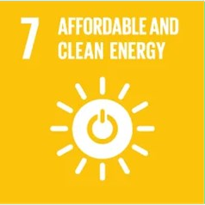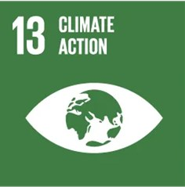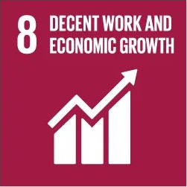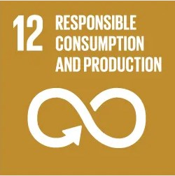

Alexandria University intends to realize further energy savings by paying close attention to energy management. All the faculties and institutes of the university realize their own energy-saving potential by means of LED lighting and the deployment of sustainable technology.

##### Alexandria University Project on using LEDs as Energy-Efficient Bulbs:

Within the framework of the University’s keenness to transform into a green, environmentally friendly university that works to enhance its resources and rationalize energy consumption, the Department of Community Service Development has launched a project for the total transformation of the used LED bulbs instead of the fluorescent ones.

The light-emitting diode (LED) bulbs are more efficient, and energy-saving compared to fluorescent bulbs, with a relatively longer life span.

The project has been implemented in phases since 2019 based on the preparation of an inventory of the total numbers needed for all faculties and institutes of the university. The first quarter, the numbers required, which represents the types of 60 cm, 120 cm and 9 watts’ bulbs, has been spent and installed, which are almost 30%. In parallel, appropriate measures were taken to dispose of the lost fluorescent lamps through one of the companies concerned with safe disposal. The second step required the purchase and transformation of 37% of the total needs of the faculties and institutes of the university. The third step required the purchase and transformation of 25% of the total needs of the faculties and institutes of the university. During the last phase, the transformation of all remaining LED bulbs was performed (detailed in evidence file 2.1).

##### Alexandria University Program to reduce Electricity consumption from Air Conditioners and electric devices such as Computers, printers, photocopiers, surveillance cameras.

* 1. All newly purchased AC are inverter AC to reduce the electricity consumption (attached pdf file).
  2. The new electric devices such as Computers, printers, photocopiers, surveillance cameras are energy efficient devices (detailed in evidence file 2.1).
  3. All electronic devises must be shut down at night, when not used.
  4. Passive Infrared (PIR) Sensors were implemented in some Faculties for motion-activated lighting to detect changes in heat signatures when someone or something moves within the sensor's range. These sensors will be implemented in phases in for all faculties and institutes of the university.
  5. Regular Maintenance of all devices.
  6. The thermostats of the air conditioner are set at 25C, and direct sunlight is avoided by using sun protection curtains.

##### Solar Energy Center at the Faculty of Agriculture (Alexandria University)

Hybrid Renewable Energy Systems to Supply Services in Rural Settlements of Mediterranean Partner Countries.

##### The services provided by the center:

1. **Research and development**: Encouraging applied research on renewable energy at AU and through collaborations with other national and international universities. Development of hybrid systems in renewable energy and its uses in water pumping and water desalination and development of remote and desert areas. Development of research in energy from biomass and waste. Development of thermal uses of solar energy.
2. **Consultations:** Various consultations in renewable energy systems, especially hybrid systems, drying and solar heating.
3. **Education and Training:** Supporting the renewable energy education at AU. Developing and delivering courses, e-learning, workshops, training courses, and conferences on various renewable energy systems.
4. Serving the Egyptian community by providing all renewable energy information to the public.

##### Equipment at the center:

1. The center has many devices for different applications of renewable energy.
2. A hybrid system to generate electricity from the sun with a capacity of about 130 kilowatts.
3. E-learning courses on the site.



|  |  |  |  |
| --- | --- | --- | --- |
| System Application | Solar System  power kWp | Air Turbine power | Energy (kWh) |
| Wadi El-Natroon 1, Photovoltaic cells | 7 |  | 7000 |
| Wadi El-Natroon 2, Photovoltaic cells | 50 |  | 50,000 |
| Wadi El-Natroon 1, Air turbines |  | 5 | 5000 |
| Wadi El-Natroon 2, Air turbines |  | 50 | 50,000 |
| Abis Campus |  |  | 130 |
| University Main building |  |  | 20 |
|  | Total Power  (kWh) |  | 112,150 |

**Renewable Energy Sources in Campus**

##### The Faculty of Agriculture has 2 renewable energy centers and on center at the main building of the University.

1. The renewable Energy Center in Wadi El-Natroon. There are two units from the network:
   * 7 kw hybrid unit for photovoltaic cells and 5 kw for air turbine.
   * 50 kw hybrid unit for photovoltaic cells and 50 kw for air turbines (under maintenance). They are all used in student training and research for graduate students and faculty members.
2. The renewable Energy Center at the Agriculture Research and Experiments Station in Abis Campus.
   * The capacity of the center is 130 kw/h connected to the electricity grid.
3. The renewable Energy Center at the main building of the University.
   * The capacity of the center is 20 kw/h connected to the electricity grid.

|  |
| --- |
|  |
| Solar Energy Center at the Faculty of Agriculture (Alexandria University) |
|  |
| Solar Energy Center at the Faculty of Agriculture (Alexandria University) |

##### The Faculty of Science:

**Research Project:** Development and implementation of decentralized solar-energy-related innovative technologies for public buildings, in the Mediterranean Basin



|  |  |  |  |
| --- | --- | --- | --- |
| System Application | Number of modules | Solar System  kWp | Power  (kWh) |

|  |  |  |  |
| --- | --- | --- | --- |
| BIPV façade brise-  soleil | 120 | 17.28 | 26350 |
| BIPV garden pergola | 90 | 8.1 | 23270 |
| BIPV roof pergola | 30 | 4.1 |
|  | Total Power (kWh) |  | 49,620 |

##### Environmental Benefits

|  |  |
| --- | --- |
| Life time CO2 emission savings | 556,935 kg |
| Life time SO2 emission savings | 2,004 kg |
| Life time NOx emission savings | 668.322 kg |

|  |
| --- |
|  |
| BIPV Façade Brise-Soleil System  Solar Energy Project at the Faculty of Science (Alexandria University) |

**The Faculty of Science:**

**Research Project**: Production of Bio-Diesel from Algae in Selected Mediterranean Countries: Med-Algae Project

##### The project objective is to explore:

1. The development of microalgae-based biodiesel production and other valuable products in six Mediterranean countries (Cyprus, Egypt, Greece, Italy, Lebanon and Malta).
2. The current level of technology, the relevant market structure, and the governmental and environmental boundaries will be mapped in the participating countries, in order to identify the most promising strategies in each country.

Studied Strains Chlorella sp was chosen to be the common examined strain between the partners. In addition, native algal strains from each participant country were isolated and identified.

Both Chlorella sp and locally isolated microalgae have been examined under lab and out-door scale.

### University administration building

The project of "supplying, installing and operating the photovoltaic solar plant with a capacity of 20.1 kW above the administration building of Alexandria University in Shatby was launched by the Arab Renewable Energy Company, on 2/14/2020. The capacity of the station per month is 20.1 kW, while the capacity consumed from the building is 255 kW / month, meaning that the station provides within 8% of the total monthly consumption. Total Solar energy per year =

**241.2 KWh**.

### Higher Institute of Public Profession

The Institute has two initiatives to exploit solar energy at the Institute through two units of photovoltaic cells (50 watts each) that are currently installed and are exploited to provide the electrical energy necessary to operate the Ultra- Filtration unit located in one of the laboratories of the Department of Materials Science for educational purpose.

Moreover, five units of photovoltaic cells (260 watts each) were installed to operate the discussion room at the Institute

and to provide it with sufficient energy for lighting purposes and to operate its display device. Total Solar energy per year

= **360 KWh**.

### The Faculty of Engineering

The implantation of the new Solar Station is completed. The implementation of the solar photovoltaic panels was performed in December 2022 with a capacity of **220** kilowatts on the 2000 m2 roof top of the building of the Mechanical Engineering Department at the Faculty of Engineering.

**Alexandria University** have generalized this initiative in some of the faculties of Alexandria University in gradual stages.

|  |
| --- |
| C:\Users\Dahlia Elmaghraby\Downloads\WhatsApp Image 2023-09-20 at 00.00.46.jpeg |
| Solar photovoltaic with a capacity of 220 kilowatts on the 2000 m2 roof top of the building of the  Mechanical Engineering Department at the Faculty of Engineering |

**Renewable energy production per year**

|  |  |  |
| --- | --- | --- |
| **No** | **Renewable Energy** | **Production (in kWh)** |
| **1** | **Solar panel** | **57,150 + 49,620 + 241.2 + 360 + 220 = 107,591.2** |
| **2** | **Windmill** | **55,000** |
|  | **Total** | **162,591.2** |

### A colorful squares with white text Description automatically generatedA colorful squares with white text Description automatically generatedThe European Union project to convert several buildings of Alexandria University into green buildings by reducing energy consumption in addition to establishing solar-powered power stations in 2023-2024

* In light of the keenness to rationalize energy consumption in university buildings and the general trend to increase the percentage of reliance on new and renewable sources in electricity production, and in cooperation with the European Union, the European Union funding was accepted for a project to transform some buildings of Alexandria University into green buildings by reducing energy consumption in addition to constructing Electrical power stations powered by solar energy on the roofs of some qualified faculty and institute buildings suitable for this purpose.
* Accordingly, three buildings belonging to the university’s faculties were chosen as a first stage to study the

feasibility of applying the project to them in terms of the building’s ability to bear the weight of solar stations to produce electricity, as well as studying the spaces available for building these stations and the extent of those spaces’ exposure to solar radiation throughout the day. The opportunities available to reduce reliance on usual energy sources were also studied in terms of using more efficient lighting, increasing reliance on natural lighting during the day, and reducing the building’s air conditioning loads.

* After research and review, the specialized scientific programs will be developed in the Faculty of Engineering, the Faculty of Education building within the Literary faculties Complex, and the Manchester Building in the Faculty of Medicine, which were chosen due to the recent construction of these buildings and their ability to accommodate the

proposed development in terms of the electrical load network and the development of air conditioning systems and water heating systems used in laboratories and bathrooms.

* These buildings were visited and their suitability for the project was evaluated. The current electricity consumption and the possibility of covering these loads with electricity generated from solar energy were studied. The roof areas facing south and suitable for establishing solar stations were inspected and raised. The available roof area in the Specialized Scientific Programs Building at the Faculty of Engineering, Alexandria University, was 2,400 square meters. It can be used to create a solar station with an area of 1,000 square meters with a capacity of **120 kilowatts**, so that the station will be able to generate **360 megawatt hours** of electricity annually. As for the Faculty of Education building, the total area of the building was 4,000 square meters, and the appropriate spaces for building the station accommodate 1,000 square meters of solar cells with a capacity of **120 kilowatts**, so that the station is capable of generating **360 megawatt hours** of electricity annually, and for the Manchester building at the Faculty of Medicine, 1,200 square meters is capable of accommodating a solar power station with an area of 800 square meters. With a capacity of **96 kilowatts**, the station is capable of generating **288 megawatt hours** of electricity annually. These stations also contribute to reducing carbon dioxide emissions by a total of approximately 214 tons annually. The total expected cost of the project is about 300,000 euros.
* The time to recover the capital was estimated through providing the electricity consumed in the three buildings for approximately seven years from the date the stations entered service at full capacity, considering the periodic maintenance necessary to continue the station’s operation with the greatest possible efficiency. Detailed reports were also prepared for each building and submitted to the general coordinator of the project, for review and to take the necessary steps to start this vital project, which is an important step in strengthening the efforts of the Egyptian state towards switching to renewable energy and reducing dependence on fossil fuels that have a negative impact on the environment.

|  |
| --- |
|  |
| The European Union project to convert several buildings of Alexandria University into green buildings by reducing energy consumption in addition to establishing solar-powered power stations: the Specialized Scientific Programs  Building at the Faculty of Engineering, the Faculty of Education Building within the Literary Colleges Complex, and the Manchester Building at the Faculty of Medicine. |

### New European Union Project for Renewable energy production (Solar panels)

|  |  |  |
| --- | --- | --- |
| **No** | **Location** | **Production (in kWh)** |
| **1** | **Faculty of Engineering** | **360,000** |
| **2** | **Faculty of Education** | **360,000** |
| **3** | **Faculty of Medicine** | **288,000** |
|  | **Total** | **1,008,000** |

**The total Renewable energy production per year in Alexandria University after the implementation of the European Union project to convert several buildings of Alexandria University into green buildings**

|  |  |  |
| --- | --- | --- |
| **No** | **Renewable Energy** | **Production (in kWh)** |
| **1** | **Solar panel** | **57,150 + 49,620 + 241.2 + 360 + 220**  **= 107,591.2** |
| **2** | **Windmill** | **55,000** |
| **3** | **New Solar panels in 2023-2024** | **360,000 + 360,000 + 288,000** |
|  | **Total** | **1,170,591.2** |

**Alexandria University new initiative is to use all the roofs of Alexandria University buildings that are suitable for the implantation of the new Solar Station is in progress.**

**Smart Building Implementation:**

|  |
| --- |
|  |
| Green building implementation through the use of sun breakers in the SSP building at the Faculty of Engineering |

## Smart Building in Alexandria University

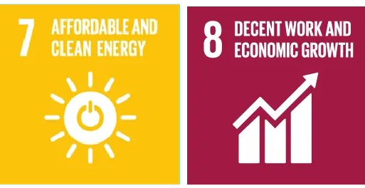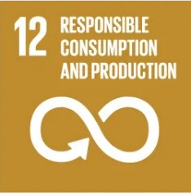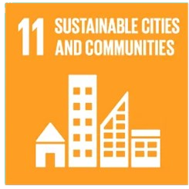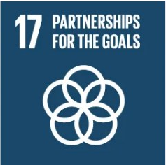

|  |  |  |  |  |  |  |  |  |  |  |  |  |  |  |  |  |  |  |  |  |  |
| --- | --- | --- | --- | --- | --- | --- | --- | --- | --- | --- | --- | --- | --- | --- | --- | --- | --- | --- | --- | --- | --- |
| **No.** | **Name** | **Place** | automation | | safety | | | | energy | | water | | Indoor environment | | | | lighting | | | | **Building Area**  (m²) |
| **B1** | **B2** | **S1** | **S2** | **S3** | **S4** | **E1** | **E2** | **A1** | **A2** | **I1** | **I2** | **I3** | **I4** | **L1** | **L2** | **L3** | **L4** |
| 1 | University Alexandria; Abis Campus, Buildings  1-11 | Alexandria, Egypt |  |  | **x** | **x** | **x** | **x** | **x** | **x** | **x** | **x** | **x** | **x** | **x** | **x** | **x** | **x** | **x** | **x** | **667,730.988** |
| 2 | University administration building | Alexandria, Egypt |  | **x** |  | **x** | **x** |  | **x** | **x** | **x** | **x** | **x** | **x** | **x** | **x** | **x** | **x** | **x** | **x** | **1940** |
| 3 | Faculty of Physical Education for Boys | Alexandria, Egypt |  | **x** |  | **x** | **x** |  | **x** | **x** | **x** | **x** | **x** | **x** |  | **x** | **x** | **x** | **x** | **x** | **113311.93** |
| 4 | Faculty of Physical Education for Girls | Alexandria, Egypt |  | **x** |  | **x** | **x** |  | **x** | **x** | **x** | **x** | **x** | **x** |  | **x** | **x** | **x** | **x** | **x** | **2891** |
| 5 | The medical complex | Alexandria, Egypt |  | **x** |  | **x** | **x** |  | **x** | **x** | **x** | **x** | **x** | **x** |  | **x** | **x** | **x** | **x** | **x** | **91216** |
| 6 | Faculty of Science in Horia Street | Alexandria, Egypt |  | **x** |  | **x** | **x** |  | **x** | **x** | **x** | **x** | **x** | **x** |  | **x** | **x** | **x** | **x** | **x** | **22197** |
| 7 | Faculty of Science in Moharram Bek | Alexandria, Egypt |  | **x** |  | **x** | **x** |  | **x** | **x** | **x** | **x** | **x** | **x** |  | **x** | **x** | **x** | **x** | **x** | **5485** |
| 8 | Faculty of Engineering | Alexandria, Egypt |  | **x** |  | **x** | **x** |  | **x** | **x** | **x** | **x** | **x** | **x** |  | **x** | **x** | **x** | **x** | **x** | **111034** |
| 9 | Campus of Humanities and Social Sciences | Alexandria, Egypt |  | **x** |  | **x** | **x** |  | **x** | **x** | **x** | **x** | **x** | **x** |  | **x** | **x** | **x** | **x** | **x** | **80707** |
| 10 | Faculty of fine Arts | Alexandria, Egypt |  | **x** |  | **x** | **x** |  | **x** | **x** | **x** | **x** | **x** | **x** |  | **x** | **x** | **x** | **x** | **x** | **2569** |
| 11 | Faculty of Specific Education | Alexandria, Egypt |  | **x** |  | **x** | **x** |  | **x** | **x** | **x** | **x** | **x** | **x** |  | **x** | **x** | **x** | **x** | **x** | **1194** |
| 12 | Faculty of Early Childhood Education | Alexandria, Egypt |  | **x** |  | **x** | **x** |  | **x** | **x** | **x** | **x** | **x** | **x** |  | **x** | **x** | **x** | **x** | **x** | **1407** |
| 13 | Medical Research Institute (Horia Street - Smouha) | Alexandria, Egypt |  | **x** |  | **x** | **x** |  | **x** | **x** | **x** | **x** | **x** | **x** |  | **x** | **x** | **x** | **x** | **x** | **2500** |

|  |  |  |  |  |  |  |  |  |  |  |  |  |  |  |  |  |  |  |  |  |  |
| --- | --- | --- | --- | --- | --- | --- | --- | --- | --- | --- | --- | --- | --- | --- | --- | --- | --- | --- | --- | --- | --- |
| 14 | Higher Institute of Public Profession | Alexandria, Egypt |  | **x** |  | **x** | **x** |  | **x** | **x** | **x** | **x** | **x** | **x** |  | **x** | **x** | **x** | **x** | **x** | **700** |
| 15 | University land in Smouha (College of Nursing - Children's Hospital - Faculty members  residences) | Alexandria, Egypt |  | **x** |  | **x** | **x** |  | **x** | **x** | **x** | **x** | **x** | **x** |  | **x** | **x** | **x** | **x** | **x** | **105218.22** |
| 16 | Land of Mouwasat Hospital | Alexandria, Egypt |  | **x** |  | **x** | **x** |  | **x** | **x** | **x** | **x** | **x** | **x** |  | **x** | **x** | **x** | **x** | **x** | **20234.27** |
| 17 | Institute of Graduate Studies and Research | Alexandria, Egypt |  | **x** |  | **x** | **x** |  | **x** | **x** | **x** | **x** | **x** | **x** |  | **x** | **x** | **x** | **x** | **x** | **2764** |
| 18 | Faculty of Agriculture Saba Pasha | Alexandria, Egypt |  | **x** |  | **x** | **x** |  | **x** | **x** | **x** | **x** | **x** | **x** |  | **x** | **x** | **x** | **x** | **x** | **144200.934** |
|  | **Total** | |  |  |  |  |  |  |  |  |  |  |  |  | |  |  |  |  |  | **1,377,300.34** |

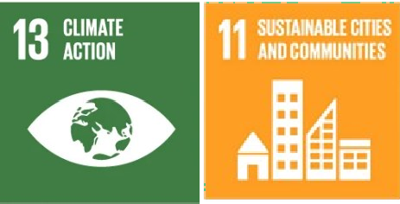*──────── Please compile one row for each building (or homogeneous part of it) by ticking with a “X” for each requirement ────────*

### Green buildings of Alexandria University are designed to reduce environmental impact through efficient use of resources and sustainable practices. The main elements of green building include:

* + Site Selection,
  + Landscaping and plantations,
  + Water Efficiency (Water Conservation, Rainwater Harvesting, and Greywater Recycling),
  + Energy Efficiency (Integrating Renewable Energy, and Lighting systems: Installing energy-efficient lighting systems such as LED)
  + Waste Management (waste reduction, and composting).

##### Applying green building concepts in the Faculty of Engineering - Alexandria University in 2020.

The buildings of the Faculty of Engineering - Alexandria University were chosen to be the nucleus from which to implement green building concepts regarding the general vision for applying environmentally friendly green building requirements to the Faculty of Engineering buildings (Report is attached in evidence file 2.3).

In the report, the faculty buildings were studied, and the summary of the report was as follows:

1. Mechanical Engineering Building: Complies with green building requirements (LEED) with the silver category.
2. Preparatory building: conforms to green building requirements (LEED) with the silver category.
3. Administration building: It does not currently comply with green building requirements (LEED), but it is possible with simple modifications to adopt it.
4. Electrical Engineering Building: It does not currently comply with green building requirements (LEED), but it is possible to adopt it with simple modifications.

##### After evaluating the Faculty of Engineering buildings, the elements of Green Building Implementation was considered

**in all building’s maintenance activity and in the construction of new buildings.**

##### Elements of Green Building Implementation as Reflected in all new construction and renovation policies:

Green building implementation in new construction and renovation policies focuses on several key elements designed to enhance sustainability, reduce environmental impact, and promote energy efficiency. These elements are typically reflected in guidelines and frameworks, such as LEED (Leadership in Energy and Environmental Design) or other local and international standards.

##### Energy Efficiency

* + Integrating solar and wind energy sources into building design reduces reliance on non-renewable resources.
  + Installing systems that optimize ventilation with minimal energy consumption.
  + Automated lighting systems that respond to occupancy or time of day.
  + As for energy, all the buildings have solar energy generation cells to provide part of the building’s needs, which

are estimated at about 45%, in addition to using energy-saving lamps (LED).

* + The public site lighting poles are powered by solar energy.

1. **Sustainable Materials:** Incorporating materials like recycled steel, concrete, or reclaimed wood.

##### Indoor Environmental Quality

* + Maximizing the use of daylight to reduce artificial lighting and improve occupant well-being.
  + Ensuring adequate ventilation and using non-toxic building materials to maintain clean indoor air.
  + Designing spaces to maintain comfortable temperatures naturally through insulation and proper orientation.

1. **Site Selection and Sustainable Landscaping:** The area of the project is 160 acres (667,730.988 m2), a general site for educational buildings, and 120 acres are complementary activities. The percentage of green areas and lake is about 52% in addition to 25% streets and lanes.

##### Water Efficiency and Reduction

* Water-saving plots are used, which will reduce water consumption by abut 30%. The sewage water will be treated and reused in the irrigation of green areas in the project.
* Rainwater is collected in the main lake and used for irrigation.
* The use of plants with few water rationed plants to reduce irrigation needs in addition to absorbing quantities of rainwater to reduce the severity of rain spells.
* Air conditioning water collection and reuse unit in Faculty of Engineering.
* Wastewater treatment unit at the Faculty of Engineering.
* Reusing wastewater from sinks, showers, and laundry for irrigation or flushing toilets.
* Using drip irrigation and other systems that minimize water use.

1. **Sustainable Transportation:** Proximity to Public Transport: Locating buildings near public transit hubs to reduce the need for private vehicle use.

Total Building Area

Total Building Area:

𝑡𝑜𝑡𝑎𝑙 𝑏𝑢𝑖𝑙𝑑𝑖𝑛𝑔 𝑎𝑟𝑒𝑎

𝑡𝑜𝑡𝑎𝑙 𝑎𝑟𝑒𝑎

× 100%

Smart building implementation

2,385,538.83 𝑚2

8,083,208.27 𝑚2 × 100% = 30%

𝑡𝑜𝑡𝑎𝑙 𝑠𝑚𝑎𝑟𝑡 𝑏𝑢𝑖𝑙𝑑𝑖𝑛𝑔 𝑎𝑟𝑒𝑎

𝑡𝑜𝑡𝑎𝑙 𝑏𝑢𝑖𝑙𝑑𝑖𝑛𝑔 𝑎𝑟𝑒𝑎

× 100%

Smart building implementation

1,377,300.34 𝑚2

2,385,538.83 𝑚2 × 100% = 57.7%

### Electricity Usage per Year (in Kilowatt hour)

|  |  |  |  |  |  |  |
| --- | --- | --- | --- | --- | --- | --- |
|  |  |  | Electricity Usage per year (kwh) |  |  |  |
|  | 12,000,000.00 |  |  |  |
|  | 10,000,000.00 |  |  |  |
|  | 8,000,000.00 |  |  |  |
|  | 6,000,000.00 |  |  |  |
|  | 4,000,000.00 |  |  |  |
|  | 2,000,000.00 |  |  |  |
|  | 0.00 |  |  |  |
|  |  | 2020/2021 2021/2022 2022/2023 | 2023/2024 |  |
| Total Electricity Usage (All Campus Locations) in 2020/2021, 2021/2022, 2022/2023, 2023/2024 (Alexandria University, Egypt)) | | | | | | |
|  | | Electricity/Gas usage in 2021/2022    Electricity Gas | | |  | |
| Total Electricity/Gas Usage ratio (All Campus Locations) in 2023/2024 (Alexandria  University, Egypt)) | | | | | | |

The total electricity consumption of Alexandria University for the academic year 2023/2024 is **4519154.69** kilowatts per hour. Total electricity use increased slightly compared to 2023 (**4329779.781** kilowatts per hour) The total electricity usage increased slightly by 1.0437% compared to year 2022/2023. Which is not a significant increase. The total gas use on the Alexandria University campus in the year 2023/2024 is **8,784 m3** (99,809 KWh), which decreased almost of 35% compared to the academic year2022/2023, where the total gas used was **13471 m3** (153,066 kWh).

**1,170,591.2 kWh / 4,519,154.69 kWh (Electricity usage) = 25.9%**

## Greenhouse gas emission reduction program

### Table: Greenhouse gas emission sources at Alexandria University Campus

|  |  |  |
| --- | --- | --- |
|  | **Emission data** | **Definition** |
| **Scope 1** | Stationary combustion | Stationary combustion refers to the burning of fuels to produce electricity, steam, and heat in a fixed location,  such as boilers, burners, heaters, kilns, and engines. |
| Mobile combustion | Burning of fuels by institution-owned transportation devices |
| Process emissions | Direct greenhouse gas (GHG) emissions from physical or chemical processes rather than from fuel combustion |
| Fugitive emissions | Hydrofluorocarbon releases during the use of refrigeration and air conditioning equipment and methane leakage from  natural gas transport |
| **Scope 2** | Purchased electricity | Indirect GHG emissions result from the generation of the electricity purchased and used by the institution |
| Energy Efficiency | Buildings and Infrastructure: |
| Renewable Energy Deployment | Solar and Wind Power: increasing the share of renewable energy in the energy mix. |
| **Scope 3** | Waste | Indirect GHG emissions resulting from the incineration or  landfill of your institution’s solid waste |
| Purchased water | Indirect GHG emissions resulting from the generation of  water supply purchased and used by the institution |
| Commuting | Indirect GHG emissions resulting from regular commuting from and to institutions by students and employees (i.e., reducing regular commuting by using shared vehicles,  carpooling) |
| Air travel | Indirect GHG emissions resulting from air travels paid by  institutions (i.e., reducing the number of staff air travel opportunities) |
| **Scope 4** | Innovation and Technology Development | Investment in Green Technologies: Support research and development in innovative technologies like hydrogen fuel cells, battery storage, and artificial photosynthesis to  capture and utilize carbon. |
| **Scope 5** | Digitalization | Promote digital solutions |
| **Scope 6** | Public Awareness and Behavioral Change | Educational Campaigns: Raise awareness about the importance of reducing GHG emissions and the role individuals can play in everyday actions, such as reducing  energy use, recycling, and adopting sustainable transport. |
| **Scope 7** | International Collaboration and Partnerships | Collaborate with other countries and institutions to share knowledge, technology, and expertise on GHG emission  reduction. |

**Scope 1, Stationary combustion and Mobile combustion**: These GHG sources are reduced by Ride Share using the University Shattle and Carpool, by the decrease of burning of fuels. Regular vehicle maintenance to reduce greenhouse gas emissions. In addition, the use of bicycles reduces the GHG source. Reducing the individual carbon footprint of students, faculty members and college employees by developing an application, prepared for smart phones. The Green Cycle project was organized by Faculty of Pharmacy- Alexandria University that enables faculty members to share cars for transportation in a safe manner in order to reduce carbon emissions resulting from car exhausts. Is project is a succeful project which was performed as a prototype at the Faculty of Pharmacy. Alexandria University’s plan is to establish the Green Cycle project in all Faculties.

**Scope 1, Fugitive emissions**: All new buildings in Abis campus are designed with large windows to get maximum benefit from daylight and natural ventilation. In addition, all University buildings have good natural ventilation and daylight. This will reduce the use air conditioning equipment and accordingly decrease GHG.

* **Alexandria University** has the lead and leadership in establishing the environmental sector and community service, and it has an effective role in preserving the environment in Alexandria and the neighboring governorates. The university, with its various colleges and institutes, is committed to implementing Law No. 4 of 1994 and its regulations. The university has environmental records for most colleges and institutes, and it also conducts environmental impact assessment studies for all its projects by consultants accredited by the Ministry of Environment.
* The university is also environmentally friendly and disposes of waste in a safe manner, as it has contracts with transportation companies for hazardous, medical, non-hazardous, solid and liquid waste.
* The university also monitors greenhouse gases and suspended and inhaled solid particles. It is committed to preserving the environment from emissions that may lead to environmental pollution and then climate change. The monitoring is carried out by faculty members who hold consultant certificates for self-monitoring of facilities, as well as environmental measurements in laboratories accredited by the Environmental Affairs Agency.
* 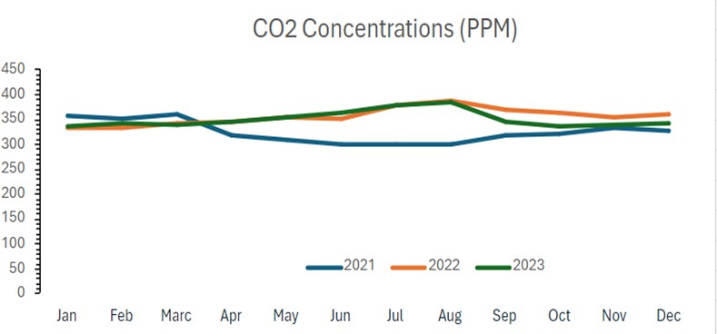Carbon dioxide has been monitored in Faculty of Science building over the past three years for 24 hours a day and the monthly averages were presented in the following graph:

This figure shows the monthly average CO2 concentration over three years (2021-2023). It is noted that CO2 concentration decreased in the period from March to September 2021, as a result of the closure during the Corona pandemic.

It is worth noting that carbon dioxide emissions during 2022 and 2023 were within the threshold limits permitted by Law

4 of 1994 due to the university’s efforts to prevent burning and the use of natural gas and solar energy.

|  |  |
| --- | --- |
|  |  |
| An application, prepared for smart phones, specific to Green Cycle project enables college members to share  cars (car pooling) for transportation (Alexandria University) | |

**Scope 2, Purchased electricity**: In light of the keenness to rationalize energy consumption in university buildings and the general trend to increase the percentage of reliance on new and renewable sources in electricity production, and in cooperation with the European Union, the European Union funding was accepted for a project to transform some buildings of Alexandria University into green buildings by reducing energy consumption in addition to constructing Electrical power stations powered by solar energy on the roofs of some qualified faculty and institute buildings suitable for this purpose.

* Accordingly, three buildings belonging to the university’s faculties were chosen as a first stage to study the feasibility of applying the project to them in terms of the building’s ability to bear the weight of solar stations to produce electricity, as well as studying the spaces available for building these stations and the extent of those spaces’ exposure to solar radiation throughout the day. The opportunities available to reduce reliance on usual energy sources were also studied in terms of using more efficient lighting, increasing reliance on natural lighting during the day, and reducing the building’s air conditioning loads.
* After research and review, the specialized scientific programs will be developed in the Faculty of Engineering, the Faculty of Education building within the Literary faculties Complex, and the Manchester Building in the Faculty of Medicine, which were chosen due to the recent construction of these buildings and their ability to accommodate the proposed development in terms of the electrical load network and the development of air conditioning systems and water heating systems used in laboratories and bathrooms.
* These buildings were visited and their suitability for the project was evaluated. The current electricity consumption and the possibility of covering these loads with electricity generated from solar energy were studied. The roof areas facing south and suitable for establishing solar stations were inspected and raised. The available roof area in the Specialized Scientific Programs Building at the **Faculty of Engineering**, Alexandria University, was 2,400 square meters. It can be used to create a solar station with an area of 1,000 square meters with a capacity of **120 kilowatts**, so that the station will be able to generate **360 megawatt hours** of electricity annually. As for the **Faculty of Education** building, the total area of the building was 4,000 square meters, and the appropriate spaces for building the station accommodate 1,000 square meters of solar cells with a capacity of **120 kilowatts**, so that the station is capable of generating **360 megawatt hours** of electricity annually, and for the Manchester building at the **Faculty of Medicine**, 1,200 square meters is capable of accommodating a solar power station with an area of 800 square meters. With a capacity of **96 kilowatts**, the station is capable of generating **288 megawatt hours** of electricity annually. These stations also contribute to reducing carbon dioxide emissions by a total of approximately 214 tons annually. The total expected cost of the project is about 300,000 euros.

As for energy, all the new buildings in Abis Campus have solar enery generation cells to provide part of the building’s needs, which are estimated at about 45%, in addition to using energy-saving lamps (LED). In addition, the public site lighting poles are powered by solar enery.

All the faculties and institutes of the university realize their own energy-saving potential by means of LED lighting and the deployment of sustainable technology. Alexandria University have generalized this initiative in some of the faculties of Alexandria University in gradual stages.

Alexandria University Program to reduce Electricity consumption from Air Conditioners and electric devices such as Computers, printers, lab apparatus**.**

1. All newly purchased AC are inverter AC to reduce the electricity consumption.
2. The new electric devices such as Computers, printers, lab apparatus are energy efficient devices.
3. All electronic devises must be shut down at night, when not used.
4. Regular Maintenance of all devices.
5. The thermostats of the air conditioner are set at 25C, and direct sunlight is avoided by using sun protection curtains

|  |
| --- |
|  |
| **Energy Efficient Appliances Usage: Use of LED lighting and lamps (New Abbes Campus, Alexandria University)** |

**Scope 3, Waste:** Implementing environmental awareness programs at the beginning of study on policies that can be followed to reduce waste production on campus, and to reduce the consumption of paper, plastic, and metals on college campuses.

Alexandria university program to reduce the use of paper and plastic in campus.

1. Development of electronic archiving system; the university faculties and the main campus are moving toward the electronic archiving system to reduce paper consumption.
2. University decree to reduce the use of paper in the campus:
   1. : The president decree to use the e-mails for communications inside the campus and between the university main campus and all the other campuses.
   2. : In the situations, the university or any of its faculties need to print the official documents; this has to be on recycled paper (2 faces copy).
   3. : The University formulated a community for administrative reform to minimize the administrative processes and decrease the use of papers except in who are relevant to financial process.
3. Digital transformation toward electronic exams to reduce paper consumption.
4. Digital transformation toward electronic course to reduce paper consumption and books printing.
5. 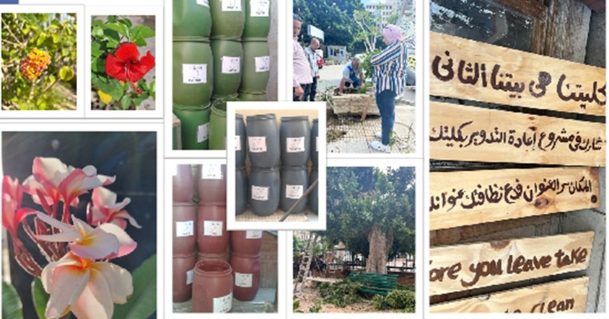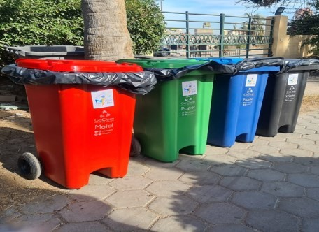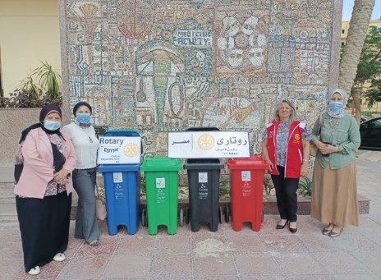Electronic administration of student courses by about 50% instead of written administration to reduce paper consumption.

**Scope 3, purchased water:** The University has applied a strategy in the faculties to decrease water consumption through installation of special parts on water taps, showers, toilette, and bathroom bidet which can conserve about 50% of water consumption. Water saving devices are used instead of traditional devices. For example, the use of a hand-washing faucet

with automatic control via a sensor, and high-efficiency bathroom devices. Supplying water taps with water conservation units. Adopting a mechanism to maintain water pipes to prevent waste resulting from leaks.

In addition, a policy for the reduction of purchased water was implented in Abis Campus 1) Water-saving plots are used, which will reduce water consumption by abut 30%. The sewage water will be trated and reused in the irrigation of green areas in the project. 2) Rainwater is collected in the main lake and used for irrigation. 3) The use of plants with few water rationed plants to reduce irrigation needs in addition to absorbing quantities of rainwater to reduce the severity of rain spells.

Also, faculty of Pharmacy is seriously seeking to implement a grey water (wastewater) recycling system that depends on reusing wastewater from sewage basins only (without using wastewater from laboratory basins) by re-pumping it into the flushing bins in the toilets after work. Filtration and primary treatment and taking advantage of rainwater for use in irrigation and regulatory operations.

**Scope 3, Commuting:** These GHG sources are reduced by Ride Share using the University Shattle and Carpool, by the decrease of burning of fuels. In addition, the use of bicycles reduces the GHG source. An application was developed for smart phones, by the students at the Faculty of Pharmacy- Alexandria University that enables faculty members to share cars for transportation in a safe manner (Green Cycle project). In addition, regular vehicle maintenance is performed to reduce greenhouse gas emissions.

##### A cooperation protocol was established with ETHYDCO to convert 10 university vehicles (Buses) into environmentally friendly grey vehicles by converting them to run on gas along with fuel.

**Scope 3, Air travel**: The University usually support the travel of Faculty members and student once every two years for attending conferences. Lately, since the covid 19 pandemic, and the increase in air travel Tickets, the support of travel was stopped.

|  |  |
| --- | --- |
|  |  |
| Grey water recycling system organized by Faculty of Pharmacy (Alexandria University) | |

##### Scope 4: Innovation and Technology Development for the Investment in Green Technologies: There are also many research projects to reduce greenhouse gas emissions, including, for example:

1. Monitoring pollutants using satellites (a project funded by the Academy of Scientific Research and Technology 2021).
2. Confronting rampant heat waves and climate change (World Bank financing 2023).
3. Confronting severe air pollution and black cloud episodes (World Bank financing 2023-2024).
4. the research project entitled: Utilizing alternative feed materials to maximize milk and meat productivity and reduce methane production in ruminants, funded by the Science and Technology Fund STDF-DDP No. 18575
5. The research project entitled Safe milk and meat production and greenhouse gas emissions from ruminants fed with the addition of nano-silt, funded by the Science and Technology Fund STDF- Innovation in the period from 2020-2023.

##### A list of 126 projects which have an impact on the reduction of greenhouse emission and climate change are listed in

**the evidence file “2.14. Impactful university program(s) on climate change”.**

##### Scope 5: Digitalization, by promoting digital solutions.

**The General Framework for Digital Transformation at the University and the Center and Units for Measurement, Evaluation, and E-Learning as a Practical Example of Digital Transformation for that Purpose.**

* 1. Alexandria University began its serious efforts to develop processes in preparation for their digitization in 2017, where a committee for development, monitoring, and administrative reform was established to analyze processes, eliminate waste, and conserve university resources. The committee also examined the merging and unification of documents for the various processes at Alexandria University and its faculties. The digital transformation of the measurement and evaluation system at Alexandria University began in 2018.
  2. The Education Development Projects Management Unit funded four projects before 2018 to establish measurement and evaluation units.
  3. Three additional projects were funded after 2018 for the digital transformation of evaluation processes in three faculties. The university also completed the digital transformation in the remaining faculties through its own efforts, utilizing resources from the electronic testing project. The total funding for the most recent project was 3,799,519 EGP, and the outcomes have reached an advanced level in areas such as question banks and the use of modern applications in practical exams.

|  |
| --- |
|  |
| **Electronic Exam Halls at the Faculty of Medicine (Alexandria University, EGYPT)** |

**Scope 6:** Public Awareness and Behavioral Change through Educational Campaigns. This is accomblished by raising awareness about the importance of reducing GHG emissions and the role individuals can play in everyday actions, such as reducing energy use, recycling, and adopting sustainable transport.

One of the success stories in Alexandria University is the establishement of the Interantional ACS Alexandria University Student Chapter, which contributed significatly since its establishment in November 2014 in the awarness students and development of skeels of the undergraduate and postgraduate students. In addition, to the outreach activity performed for the awarness of school students.

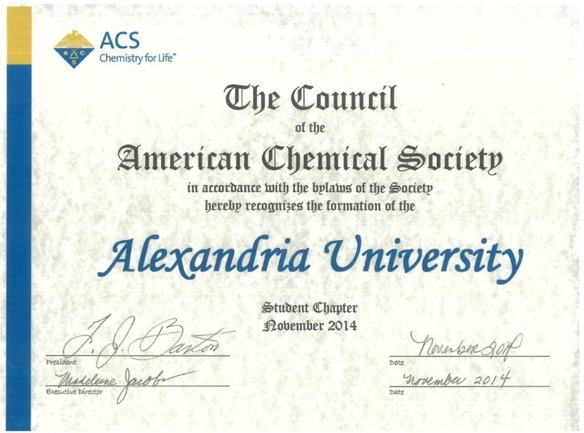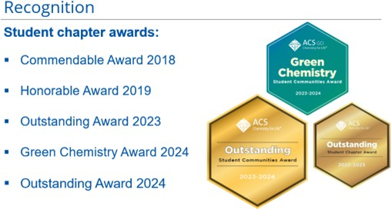

**Scope 7**: International Collaboration and Partnerships is performed by collaborating with other countries and institutions to share knowledge, technology, and expertise on GHG emission reduction.

## DUAL AND JOINT DEGREES IN NUMBERS

**Alexandria University's Research on Greenhouse Gas Emissions**

* **Researchers from various faculties at Alexandria University have been conducted 731 research articles and reviews, within 2023-2024, to mitigate the Greenhouse Gas Emissions across different scientific fields.**

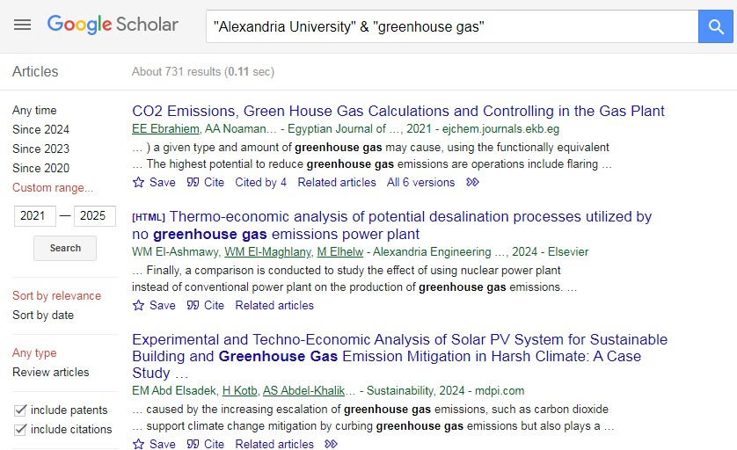

### Alexandria University’s Carbon Footprint

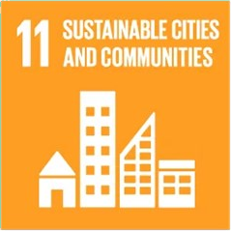

**(2023/2024)**

During the very few past years, the climate change and the

global warming facing the entire universe have gained much more attention due to their direct effects on the human life on earth. As a result, countries, organizations, and people have noticed that it is now the time to face these challenges and as an initial step, we must first determine or calculate the amount of pollution that we cause to our planet, then we shall work on ourselves to minimize this pollution. One of the most famous methods to monitor the climate change is to determine what is known by Carbon Footprint.

The term "Carbon Footprint" is usually used as shorthand for the amount of emitted carbon (in tons) by an organization or country. This footprint is also an important component of the Ecological Footprint, since it is one competing demand for biologically productive space. Carbon emissions from burning fossil fuel usually accumulate in the atmosphere if there is not enough biocapacity dedicated to absorb these emissions. Therefore, when the carbon footprint is reported [within](https://www.footprintnetwork.org/2017/11/09/ecological-footprint-climate-change/) [the context of the total Ecological Footprint,](https://www.footprintnetwork.org/2017/11/09/ecological-footprint-climate-change/) the tons of carbon dioxide emissions are expressed as the amount of productive land area required to sequester those CO2 emissions, which tells us how much biocapacity is necessary to neutralize these emissions.

Measuring Carbon Footprint in a certain area just shows us how much biocapacity is needed to take care of our untreated carbon waste and to prevent carbon accumulation in the atmosphere, which as a consequent can enable us to address the climate change challenge in a clearer way. In fact, the climate problem emerges because the planet does not have enough biocapacity to neutralize all these emissions. Humanity’s carbon Footprint has increased 11-fold since 1961. Reducing humanity’s carbon Footprint is the most essential step we can take to end overshoot and live within the means of our planet.

The climate pact approved in Paris in December 2015 represented an important step in re-imagining a fossil-free future for our planet. Nearly 200 countries around the world, including Egypt, agreed to keep global temperature rise well below 2°C. According to the known data from (Intergovernmental Panel on Climate Change) IPCC’s 2014 report that a concentration of greenhouse gases in the atmosphere of [450 ppm CO2 equivalent](https://www.ipcc.ch/pdf/assessment-report/ar5/syr/AR5_SYR_FINAL_SPM.pdf) gives us a 66% chance to comply with the Paris Agreement’s (2°C) goal. In contrast, the National Oceanic and Atmospheric Administration of the United States Department of Commerce (or NOAA) reports that in 2020 we were already at [504 ppm CO2 equivalent.](https://www.esrl.noaa.gov/gmd/aggi/aggi.html) This confirms that the problem is increasing and there is a critical demand to rapidly solve it. Although Egypt contributes with a small portion in the global emissions of greenhouse gases, but this small portion is growing with time. In addition, Egypt is also expected to suffer from shortage of water, decrease in agricultural crops, rising sea levels due to increase in temperature and change in rainfall patterns.

In the light of the above mentioned information and according to the "Sustainable Development Strategy: Egypt's Vision 2030", Alexandria University, as a very important educational institution, has took the first steps to work on reducing carbon emissions as one of the most important sources of greenhouse gases and has implemented a plan to monitor and calculate the “Carbon Footprint since the academic year 2018 / 2019” for all its faculties, institutes and its administrative buildings in order to aid in decision-making.

When calculating the Carbon Footprint for all Alexandria University buildings for the Academic year (2023/2024), the approximate amount of emitted CO2 was **4,284.13765 CO2e.**

### The total carbon footprint of the Faculties and Institutes of Alexandria University (Ton CO2e)

|  |  |  |  |  |
| --- | --- | --- | --- | --- |
| **Faculty/Institute** | **2020/2021** | **2021/2022** | **2022/2023** | **2023/2024** |
| **University Administration Building** | **NA** | **186.330** | **257.8696** | **235.6893** |
| **Faculty of Arts** | **235.887** | **179.299** | **126.5596** | **174.3114** |
| **Faculty of Commerce** | **412.128** | **29.3102** | **134.991** | **128.3933** |
| **Faculty of Education** | **21.807** | **9.264** | **28.61872** | **12.7546** |
| **Faculty of Medicine** | **1817.232** | **433.984** | **528.7561** | **442.4181** |
| **Faculty of Dentistry** | **705.702** | **29.379** | **301.0882** | **250.8576** |
| **Faculty of Engineering** | **693.748** | **675.702** | **530.7443** | **543.4759** |
| **Faculty of Agriculture** | **1326.267** | **1066.346** | **743.709** | **739.2388** |
| **Faculty of Pharmacy** | **318.059** | **306.118** | **273.1078** | **205.75421** |
| **Faculty of Science** | **317.362** | **218.947** | **222.71091** | **148.0105** |
| **Faculty of Nursing** | **122.79** | **161.580** | **140.3059** | **169.1397** |
| **Faculty of Veterinary Medicine** | **186.221** | **172.431** | **144.0973** | **157.2076** |
| **Higher Institute of Public Health** | **12.646** | **59.204** | **51.1156** | **48.2525** |
| **Medical Research Institute** | **555.478** | **186.894** | **144.438** | **186.7957** |
| **Institute of Graduate Studies and Research** | **10.92** | **7.246** | **16.0455** | **14.9636** |
| **Faculty of Physical Education for**  **girls** | **277.671** | **380.872** | **306.9452** | **309.61494** |
| **Faculty of Physical Education for boys** | **214.835** | **319.100** | **235.999** | **192.7736** |
| **Faculty of Specific Education** | **12.069** | **3.613** | **11.8411** | **11.8663** |
| **Saba Pasha Faculty of Agriculture** | **92.785** | **109.632** | **98.6493** | **80.0543** |
| **Faculty of Education for Early**  **Childhood** | **33.4747** | **4.745** | **19.0013** | **24.3051** |
| **Faculty of Fine Arts** | **22.654** | **19.541** | **20.6138** | **20.8157** |
| **Faculty of Tourism and Hotels** | **9.924** | **4.525** | **6.5065** | **3.9269** |
| **Faculty of Law** | **141.668** | **151.137** | **147.9066** | **183.5180** |
| **Total** | **7,541.33 CO2e** | **4,715.1992 CO2e** | **4,491.62033 CO2e** | **4,284.13765 CO2e** |

This report came out as a result of the concerted efforts of the academic community of Alexandria University during the academic year 2023/2024 in collecting, analyzing and editing this report in accordance with international standards and controls for carbon footprint calculations.

In order to allocate the specific position of Alexandria University regarding the extent of its contribution to carbon emissions among similar institutions, it was necessary to compare these emissions with other universities around the world.

|  |  |  |
| --- | --- | --- |
| **University** | **Last Carbon Footprint**  **Report** | **Carbon Footprint Total value (metric**  **tons)** |
| **American University in Cairo (AUC)** | **2019/2020** | **34,391.3 CO2e** |
| **Cape Town University (Republic of South Africa)** | **2018** | **75,187 CO2e** |
| **Arizona University (USA)** | **2017** | **258,088 CO2e** |
| **Alexandria University (Egypt)** | **2022/2023** | **4,491.62033 CO2e** |
| **Alexandria University (Egypt)** | **2023/2024** | **4,284.13765 CO2e** |

**Conclusion:**

According to the Carbon Footprint for all Alexandria University buildings for the Academic year (2023/2024), which is approximately 4,284.13765 CO2e, one can conclude that the sustainability program of Alexandria University was successful. The total electricity consumption of Alexandria University for the academic year 2023/2024 is **4519154.69** kilowatts per hour. Total electricity use increased slightly compared to 2023 (**4329779.781** kilowatts per hour) The total electricity usage increased slightly compared to year 2022/2023. Which is not a significant increase. The total gas use on the Alexandria University campus in the year 2023/2024 is **8,784 m3** (99,809 KWh), which decreased almost of 35% compared to the academic year2022/2023, where the total gas used was **13471 m3** (153,066 kWh). On the main campus area of Alexandria University electricity is used for lighting, cooling, heating and laboratory appliances.

On the other hand, a significant decrease in the consumption of paper packages is observed. The paper packages used in all Alexandria University buildings for the Academic year (2020/2021) was 84689 paper packages. While in the year (2021/2022) it was reduced to 47911 packages. In the academic year (2022/2023), the consumed paper packages slightly increased to reach 55712 packages. In the academic year (2023/2024), the consumed paper packages reached **46876 packages**.

## Number of innovative program(s) in energy and climate change & Impactful university program(s) on climate change

##### The Faculty of Agriculture has 2 renewable energy centers and one center at the main building of the University. (Previously presented)

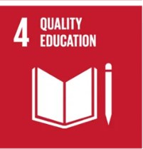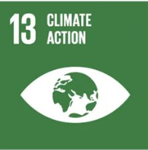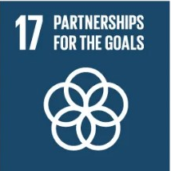

1. S**olar Energy Center at the Faculty of Agriculture (Alexandria University): (Previously presented)**

##### The Faculty of Science: (Previously presented)

**Research Project:** Development and implementation of decentralised solar-energy-related innovative technologies for public buildings, in the Mediterranean Basin

##### The Faculty of Science: (Previously presented)

**Research Project**: Production of Bio-Diesel from Algae in Selected Mediterranean Countries: Med-Algae Project

##### Smart Environmental Management of Climate Change in collaboration with Catania University, Italy

2 year Postgraduate Master program (4 semesters).

AdapTm-Erasmus project: The participating countries and Universities: Italy, Greece, Lithuania, Slovenia, Egypt (Alexandria University, Suez Canal University, South Valley University, Arab Academy for Science and Technology and Maritime Transport).

Program start date: year 2019

##### Link: https://emuni.si › ADAPTM-handout_2_Mod

|  |  |
| --- | --- |
| **5** |  |
|  | Smart Environmental Management of Climate Change Master Program (Alexandria University, Egypt) |
| **6** |  |
|  | Sustainable Management of Fisheries and Aquaculture Science Master Program (Alexandria University, Egypt) |

|  |  |
| --- | --- |
| **7** |  |
|  | Natural Resources Sustainability for Land Development Master Program (Alexandria University, Egypt) |

1. **Sustainable Management of Fisheries and Aquaculture Science, in collaboration with University of Aveiro, Portugal.**

2 year Postgraduate Master program (4 semesters).

(Erasmus+ Project, European Union): The participating countries and Universities: Portugal (University of Aveiro), Italy, Croatia, Slovenia, Egypt (Alexandria University, Aswan University, Matrouh University, Arab Academy for Science and Technology and Maritime Transport).

Program start date: year 2021

**Link:** [**http://fishaqu.eu**](http://fishaqu.eu/)

1. **Natural Resources Sustainability for Land Development in collaboration with Aachen University, Germany**

2 year Postgraduate Master program (4 semesters).

Erasmus+ Project, European Union: The participating countries and Universities: Germany (RWTH Aachen), Egypt (Alexandria University, Heliopolis University, the American University in Cairo, Aswan University), Cyprus (CITY College – Sheffield University), Italy (University of Palermo), Spain (Technical University of Madrid).

Program start date: year 2022

##### Link:

YouTube: [https://suremap.eu](https://suremap.eu/)

facebook: <https://www.facebook.com/suremapproject> LinkedIn: https:/[/w](http://www.linkedin.com/company/suremap-project)w[w.linkedin.com/company/suremap-project](http://www.linkedin.com/company/suremap-project)

##### The Faculty of Engineering - Alexandria University

The implantation of the new Solar Station is completed. The implementation of the solar photovoltaic panels was performed in December 2022 with a capacity of **220** kilowatts on the 2000 m2 roof top of the building of the Mechanical Engineering Department at the Faculty of Engineering.

**Alexandria University** have generalized this initiative in some of the faculties of Alexandria University in gradual stages.

##### Green Cycle project in the Faculty of Pharmacy - Alexandria University

Within the framework of the Faculty of Pharmacy’s tireless endeavour to meet the needs of the community inside and outside the university and to contribute to solving contemporary health, social and economic problems, in line with the vision of Alexandria University, which is based on the principles of comprehensive quality and continuous and sustainable development, in harmony with the state’s development plan “Sustainable Development Strategy: Egypt Vision 2030”: The college is advancing the “Green Circle” project, which is a non-profit project that seeks to keep the environment clean and green in a sustainable way by growing plants to increase green spaces, as well as separating waste for recycling and establishing charitable markets to benefit from used clothes and use electricity-saving alternatives such as energy saving lamps.

|  |
| --- |
|  |
| Car pooling application for smartphones - Green Cycle project in the Faculty of Pharmacy (Alexandria University, Egypt) |

The project began in October 2022 by organizing a number of events in cooperation between the Community Service and Environmental Development Committee, ASPSA, and the Alexandria Rotary Clubs, under the supervision and organization of Faculty of Pharmacy - Alexandria University.

Also, the faculty is seriously seeking in the next stage to implement a grey water (wastewater) recycling system that depends on reusing wastewater from sewage basins only (without using wastewater from laboratory basins) by re- pumping it into the flushing bins in the toilets after work. Filtration and primary treatment.

##### Project goals:

* 1. Spreading awareness of the need to maintain the cleanliness of the Faculty of Pharmacy campus.
  2. Spreading green spaces and landscaping on the campus of the Faculty of Pharmacy.
  3. Reuse of wastewater from septic tanks only by pumping it back into the flushing bins of the toilets after primary treatment.
  4. Taking advantage of rainwater for use in irrigation and regulatory operations.
  5. Reducing the individual carbon footprint of students, faculty members and college employees by developing an application, prepared for smart phones, specific to the project that enables college members to share cars for transportation in a safe manner in order to reduce carbon emissions resulting from car exhausts.
  6. Waste recycling, the most important of which is paper collection, as it has one of the highest recycling rates more than any other waste at the University.

The Green Circle Project is an integrated system that has many positive and direct impacts on the environment at the Faculty of Pharmacy, and provides a model that can be emulated in the colleges and institutes of Alexandria University, as providing a clean, sustainable environment has good effects on the mental and physical health of students, faculty members, and college workers, which makes them feel its value. They like to be there and keep it clean. Therefore, this project will lead to indirect results on the productivity of college employees, as well as transferring them to a culture of sustainability in preserving the environment outside the college walls.

The grey water recycling initiative has a significant impact on rationalizing water use and thus saving the college’s monthly

water bills, which constitute a burden on the budget.

Introducing the concept of car sharing among university students will reduce the costs of going to college. Also, the presence of students and workers in a clean environment will improve overall performance.

##### What has been implemented of the project so far

* The trees around the college campus were trimmed, cut, sprayed, and maintained, and the plants spread at the college entrance were taken care of.
* Attention was paid to recycling wood waste from exam tables and chairs and converting them inside the college workshops with carpenters from the college into boxes for flowers and plants.
* A partnership contract was signed with some parties to dispose of hazardous waste.
* Awareness seminars were held for college members about the importance of preserving the environment and educating young people about climate change.
* 23 waste collection points have been distributed for recycling.
* 75 seedlings of ornamental plants were planted to create an aesthetic appearance and work to increase the green area. These plants are being cared for and increased in number.
* A running and walking marathon was held to encourage reduced use of strollers.
* Many charity markets have been set up to recycle clothes.
* The faculty lighting has been changed to use energy saving lamps.
* A complete design for grey water recycling has been developed and is awaiting university approvals.
* A team of faculty students developed an application, prepared for smartphones, to serve the project ideas and encourage active participation in it. The first phase has been completed and will be launched simultaneously with the study.
* A preliminary concept for rooftop farming has been developed.
* Planning to plant the faculty wall has been completed and is awaiting university approvals.

##### Future plan of the project:

* Increasing the rates of afforestation within the college and increasing the green area in the college through two main axes:
* Cultivation of the college’s surfaces.
* Constructing a wall parallel to the college wall, 55 meters long and 40 centimetres deep. This wall contains 40 fruit trees, including lemon, olive, and orange trees. This phase will begin in September 2023.
* Launching the application for smartphones.
* Implementing environmental awareness programs at the beginning of study on policies that can be followed to reduce waste production on campus, and to reduce the consumption of paper, plastic, and metals on college campuses.
* Preparing an integrated file about the initiative in the universities and schools and communicating with the Governor of Alexandria to activate the idea. In various government facilities in Alexandria, which brings financial and environmental benefits to the bride of the Mediterranean.
* Generalizing the initiative to the rest of the governorates of the Arab Republic of Egypt, ensuring a cleaner environment and a less polluted and brighter future for future generations.

##### Green circle supplement:

**Medicinal plant extraction unit (Environmentally friendly unit):**

The medicinal plant extraction unit is a model unit for preserving the environment and its resources greatly because it contains devices that help reduce the use of organic solvents that are harmful to the environment and reduce water waste in general.

1. **Renewable sources in electricity production project in cooperation with the European Union in Alexandria University buildings in 2023-2024**

* In light of the keenness to rationalize energy consumption in university buildings and the general trend to increase the percentage of reliance on new and renewable sources in electricity production, and in cooperation with the European Union, the European Union funding was accepted for a project to transform some buildings of Alexandria University into green buildings by reducing energy consumption in addition to constructing Electrical power stations powered by solar energy on the roofs of some qualified faculty and institute buildings suitable for this purpose.
* Accordingly, three buildings belonging to the university’s faculties were chosen as a first stage to study the feasibility of applying the project to them in terms of the building’s ability to bear the weight of solar stations to produce electricity, as well as studying the spaces available for building these stations and the extent of those spaces’

exposure to solar radiation throughout the day. The opportunities available to reduce reliance on usual energy sources were also studied in terms of using more efficient lighting, increasing reliance on natural lighting during the day, and reducing the building’s air conditioning loads.

* After research and review, the specialized scientific programs will be developed in the Faculty of Engineering, the Faculty of Education building within the Literary faculties Complex, and the Manchester Building in the Faculty of Medicine, which were chosen due to the recent construction of these buildings and their ability to accommodate the proposed development in terms of the electrical load network and the development of air conditioning systems and water heating systems used in laboratories and bathrooms.
* These buildings were visited and their suitability for the project was evaluated. The current electricity consumption and the possibility of covering these loads with electricity generated from solar energy were studied. The roof areas facing south and suitable for establishing solar stations were inspected and raised. The available roof area in the Specialized Scientific Programs Building at the **Faculty of Engineering**, Alexandria University, was 2,400 square meters. It can be used to create a solar station with an area of 1,000 square meters with a capacity of **120 kilowatts**, so that the station will be able to generate **360 megawatt hours** of electricity annually. As for the **Faculty of Education** building, the total area of the building was 4,000 square meters, and the appropriate spaces for building the station accommodate 1,000 square meters of solar cells with a capacity of **120 kilowatts**, so that the station is capable of generating **360 megawatt hours** of electricity annually, and for the Manchester building at the **Faculty of Medicine**, 1,200 square meters is capable of accommodating a solar power station with an area of 800 square meters. With a capacity of **96 kilowatts**, the station is capable of generating **288 megawatt hours** of electricity annually. These stations also contribute to reducing carbon dioxide emissions by a total of approximately 214 tons annually. The total expected cost of the project is about 300,000 euros.
* The time to recover the capital was estimated through providing the electricity consumed in the three buildings for approximately seven years from the date the stations entered service at full capacity, considering the periodic maintenance necessary to continue the station’s operation with the greatest possible efficiency. Detailed reports were also prepared for each building and submitted to the general coordinator of the project, for review and to take the necessary steps to start this vital project, which is an important step in strengthening the efforts of the Egyptian state towards switching to renewable energy and reducing dependence on fossil fuels that have a negative impact on the environment.

### New European Union Project for Renewable energy production (Solar panels)

|  |  |  |
| --- | --- | --- |
| **No** | **Location** | **Production (in kWh)** |
| **1** | **Faculty of Engineering** | **360,000** |
| **2** | **Faculty of Education** | **360,000** |
| **3** | **Faculty of Medicine** | **288,000** |
|  | **Total** | **1,008,000** |

|  |  |
| --- | --- |
| **10** |  |

##### Fab Lab Project in the Faculty of Engineering - Alexandria University

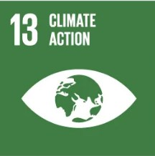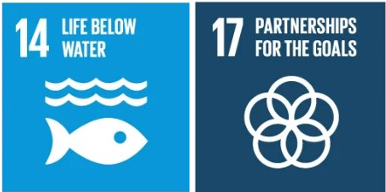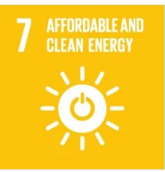

The European Union project to convert several buildings of Alexandria University into green buildings by reducing energy consumption in addition to establishing solar-powered power stations: the Specialized Scientific Programs Building at the Faculty of Engineering, the Faculty of Education Building within the Literary Colleges Complex, and the Manchester Building at the Faculty of Medicine.

The overall goal of the project is to develop the circular and creative economy model by creating an innovation place equipped with machines Low Tech in Alexandria is hosted by Alexandria University. This place will play a role in creating local dynamism Transversal to become a crossroads between different audiences and actors from different backgrounds. To connect waste collection Plastic and its evaluation. Horizons Solidarités and the University of Corsica, in partnership with their peers in Alexandria, based on their experience in Fab Lab Corte, conduct experiments on recreating value for plastic in Alexandria. The goal is to connect all actors from assembly through training to development and dissemination (Discussed in detail in page 23, 24).

##### The scope of work in the project

* **Environment, climate, and energy**

##### Education, social aspect, and research

These goals will be implemented through the establishment of a FabLab within Alexandria University, which is a space for innovation. Derives place this innovation is energized by a generation that has innovative ideas in the fields of environment, citizenship, and culture. This revival is embodied in women and the men who are partners in the project. The high skills of Alexandria University and Senghor University, Francophone operator in Alexandria, ensures the long-term commitment of their students and the sustainability of the local dynamism. Implementation benefits from facilities Headquarters provided by Alexandria University Project Engine. VSI contributes to the unification of links between regions. Project depends on the Alexandria Business Association (ABA), a trade organization that invests in creating startups in the circular economy and selling finished products. A multi-representative consortium from both sides of the Mediterranean could be formed from these dynamics that will support the project over time.

The French side confirmed that the Fab Lab at the University of Corsica in France has become a very successful experiment on the economic and environmental levels, and is considered one of the most important strategic projects in France and receives the attention of the French Presidency and the Mediterranean region. The French side explained that it seeks to benefit from the expertise of Alexandria University, and that they are fully prepared. To provide full support for the project and coordinate with the relevant authorities in France for the success of this experiment, which will benefit both sides on the environmental, economic and environmental levels.

Led by the South Region and its partner Alexandria Governorate, this project aims to be part of an inter-regional dynamic with the participation of the **Corsican community**. This project is part of the “Zero Plastic Waste” regional strategy in the Mediterranean. It is also part of the dynamics of the memorandum signed on September 5, 2022 between the region and IUCN Med on the occasion of the World Nature Congress in Marseille, which aims to develop joint actions for the benefit of a Mediterranean region without plastic. On the other hand, this project is part of the context of the twenty-seventh session of the Conference of the Parties held in Egypt. It joins the global effort undertaken by the Egyptian state in order to effectively combat the effects of climate change. Its realization in Alexandria makes it possible to structure a permanent cooperation with the governorate around a symbolic project that will, in the long term, enhance the social impact of research and university cooperation. In addition, this project promotes decentralized cooperation between the three regions.

Indeed, supporting this project will highlight the role of the region, Alexandria Governorate, and Corsica in supporting innovative solutions to adapt regions to changing Climate. The strategy is based on four pillars: **digital communication in three languages**, **the production of digital communication media intended for the general public**, **organizing competitions for artists and architects from the two countries to enhance the innovative role Fab Lab**, **and discussions of ideas supported by all partners as a regional facilitator**. In addition, a dedication ceremony for the Fab Lab will be held in the presence of elected officials, governors, university presidents, and will be followed by the symposium in Alexandria is a continuation of COP 27, which was held in November 2022.

A system for monitoring and evaluating the project will be developed by members of the steering committee with the support of specialists. The monitoring and evaluation system will include the quantitative, qualitative, and financial components of the project. It will make it possible to measure the effectiveness of this place of innovation as a driver of sustainable and inclusive development at the local and Mediterranean levels. Indicators for this monitoring and evaluation system will be identified and validated by the Steering Committee at the beginning of the project to verify throughout the

implementation period whether the results are consistent expected meets set goals. Answers will need to be provided to the items specified in the reference system approved by the Steering Committee.

##### Link for Fab Lab Project

https:/[/w](http://www.instagram.com/ecofab_alexandria/)w[w.instagram.com/ecofab_alexandria/](http://www.instagram.com/ecofab_alexandria/)

https://alexu.edu.eg/index.php/en/important-news/9096-president-of-alexandria-university-inaugurates-the-fab-lab- for-reusing-plastic-peca

|  |  |
| --- | --- |
| **11** |  |
|  |

|  |  |
| --- | --- |
|  |  |
|  | Eco Fab Alexandria  The Eco Fab is a fab lab dedicated to plastic recycling in Alexandria, Egypt and part of PECA project (Circular economy hub in alexandria). |

##### Awareness program toward energy and Climate Change was implemented by Alexandria university through initiatives, symposia, conferences, workshops, and activities.

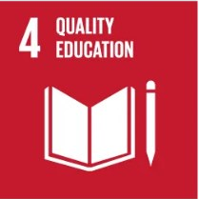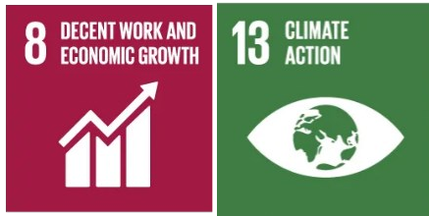

* + **Researchers from various faculties at Alexandria University have conducted 2080 research articles and reviews, within 2023-2024, to investigate the phenomenon of climate change across different scientific fields.**

|  |
| --- |
|  |

##### Planning, implementation, monitoring and/or evaluation of all programs related to Energy and Climate Change through the utilization of Information and Communication Technology (ICT)

|  |  |  |  |  |  |
| --- | --- | --- | --- | --- | --- |
| **Stage** | **Activities/Programs** | **ICT Utilization** | **Evidence** | **Timeline** | **Responsible Team/Departme nt** |
| Planning | Assess potential for renewable energy installations | IoT-Based Agroecological Farming Project, Motion-Activated Lighting with PIR Sensors, Automated Lighting Systems, and Renewable Energy Installation Plan | Feasibility studies, website links | Nov 2023- Dec  2023 | Energy Management, ICT Dept |
| Implementa tion | Install solar panels, wind turbines and Biodiesel production unit | Project installation tools | Installation logs, energy generation data | Jan 2024 - June 2024 | Facility Management |
| Monitoring | Track renewable energy production | Renewable energy monitoring systems | Energy production reports, performance analytics | Ongoing | Information and Documentation Center for Decision Support at Alexandria University |

**Description:**

##### Number of renewable energy sources on campus

* + **Planning:**

1. **Motion-Activated Lighting with PIR Sensors**

PIR sensors have been installed in select faculties to enable motion-activated lighting by detecting changes in heat signatures. Gradual implementation of PIR sensors across all faculties and institutes of the university, as a future phase.

1. **Automated Lighting Systems**

Install lighting systems that automatically adjust based on occupancy or time of day to enhance energy efficiency.

1. **IoT-Based Agroecological Farming Project**
   * **Location**: Alexandria University Farm
   * **Implementation Partner**: Shanghai Water Saving Irrigation Corp.
   * **Project Overview**: Develop and implement an automated irrigation system using IoT technology to support modern irrigation practices.
   * **Goals**: Efficient irrigation of economically important crops, and enhancement of irrigation systems to mitigate the freshwater scarcity in Egypt.
2. Renewable Energy Installation Plan
3. **Solar Photovoltaic (PV) Systems**

Install solar PV systems to harness solar energy for electricity generation.

* + **Steps**:
* Conduct site assessments to determine optimal locations.
* Install solar panels and connect them to the electrical grid.
* Implement ongoing maintenance to ensure system efficiency.

#### Wind Energy Systems

* Utilize wind turbines to generate electricity from wind energy.
  + **Steps**:
* Identify suitable sites with adequate wind resources.
* Install wind turbines and integrate them with the power grid.
* Perform regular maintenance to maximize performance.

C) Biodiesel Production

* + Utilize algae to generate efficiently and sustainably produce high-quality biodiesel.
    - **Steps**:
* Identify algal strains.
* Mass production and transesterification process.
* purifying the biodiesel, testing quality of the final product.

##### Implementation:

setting up renewable energy sources: solar panels, wind turbines, and Biodiesel production.

##### The Faculty of Agriculture has 2 renewable energy centers and on center at the main building of the University.

* S**olar Energy Center at the Faculty of Agriculture (Alexandria University)**

##### Renewable sources in electricity production project in cooperation with the European Union in Alexandria University buildings in 2023-2024

* **Alexandria University new initiative is to use all the roofs of Alexandria University buildings that are suitable for the implantation of the new Solar Station is completed.**

##### IoT-based agroecological farming project has been launched at Alexandria University Farm, spearheaded by Shanghai Water Saving Irrigation Corp.

|  |
| --- |
|  |
| **An innovative IoT-based agroecological farming project has been launched at Alexandria University Farm,**  **spearheaded by Shanghai Water Saving Irrigation Corp.** |
| **Solar Panels and Wind Turbines** |

|  |
| --- |
|  |
| **Example of Windmill and Solar Panels (Solar Energy Center at the Faculty of Agriculture - Alexandria University)** |
|  |
| **Solar Energy Center at the Faculty of Agriculture (Alexandria University)** |
|  |
| **Solar Panels (Solar Energy Center at the Faculty of Agriculture - Alexandria University)** |

|  |
| --- |
|  |
| **Solar Energy Center at the Faculty of Science (Alexandria University)** |
|  |
| **BIPV Roof Pergola, Faculty of Science in Moharram Bek (Alexandria University)** |
|  |
| **BIPV Garden Pergola, Faculty of Science in Moharram Bek (Alexandria University)** |
|  |
| **Solar photovoltaic with a capacity of 220 kilowatts on the 2000 m2 roof top of the building of the**  **Mechanical Engineering Department at the Faculty of Engineering** |

|  |
| --- |
|  |
| **The European Union project to convert several buildings of Alexandria University into green buildings by reducing energy consumption in addition to establishing solar-powered power stations: the Specialized Scientific Programs Building at the Faculty of Engineering, the Faculty of Education Building within the Literary Colleges Complex, and**  **the Manchester Building at the Faculty of Medicine.** |
|  |
| **Green building implementation through the use of sun breakers in the SSP building at the Faculty of Engineering** |
| **Bio-Diesel Production** |
|  |
| **Production of Bio-Diesel from Algae in Selected Mediterranean Countries: Med-Algae Project (Faculty of Science, Alexandria University)** |

|  |  |
| --- | --- |
|  | |
| **Algae Cultivated In Flat Panel Photo-Bioreactor, Med- Algae Project (Faculty of Science, Alexandria University)** | **Open Ponds with running algal cultures, Med-Algae Project (Faculty of Science, Alexandria University)** |

* **Monitoring:** Use renewable energy monitoring systems to track energy production, generating performance reports and analytics.
* **Alexandria University campus generates 1,170,591.2 kilowatt-hours (kWh) of renewable energy annually. When compared to the campus’s total annual electricity consumption of 4,519,154.69 kWh, this renewable energy production accounts for 25.9% of the total energy used. More than a quarter of the campus’s electricity needs are met by renewable energy sources. This indicates a significant contribution of renewable energy to the campus’s overall energy consumption, reducing reliance on non-renewable energy sources.**

|  |  |  |
| --- | --- | --- |
| **No** | **Renewable Energy** | **Production (in kWh)** |
| **1** | **Solar panel** | **1,115,591** |
| **2** | **Windmill** | **55,000** |
| **Total** | | **1,170,591.2** |